|  |
| --- |
| Faculty of Applied Sciences and Technology |
| **J2EE web application:ABC Protection Plan** |
| ITE5332 - Project |
|  |
| **Kien Tran – Chi Bui** |
| **11/16/2019** |

|  |
| --- |
| This is the ITE5322 Project which students design a web application using J2EE/JSP/JSTL |

Table of Contents

Section 1 : Analysis 2

Section 2: Database Design 4

Section 3 : Design Webforms 6

Section 4 : JSP/JSTL codings 13

Section 5 : New functionality 20

Section 6: Program execution/output 21

Section 7: How to Deploy the Web application 32

Section 8: Project Feedback 33

# Section 1 : Analysis

(Describe how you plan to solve the problem including steps that you take in this project and how you divide the work in your group.

Prepare/add all related Software Analysis/Design documents)

## Our Plan:

Our plan to solve the problem: based on the requirements, we break down the main objects and main functions as below. Then we separate the task base on the object and the flow of User and Admin

* Kien to do the common function, Admin page, function for admin
* Chi to do the User page, function for user

Next, we specified the detail page name associated with functions

## Here is the detail analysis

* There are 4 main objects: Users (included normal user and Admin), Product, Protection registration (registered products), Claim.

### Common functions for user and admin

* Login –login.jsp and based on the permission defined in authorization.jsp each type of user will have the right to access its own page which also defined in authorization.jsp.
* Logout – logout.jsp : reset all the values (username, password, role) and redirect to login page.
* Permission: based on role attribute – authorization.jsp

### Functions for user: After login user can register, submit claim and search as below

* Register – register.jsp
* Register product – register_product_list.jsp
* Search registered product – built in register_product_list.jsp
* Submit claim - protection_claim.jsp
* List user claim – user_claim_list.jsp
* Search submitted claim – built in user_claim_list.jsp

### Functions for Admin: after login user can CRUD product, list products, list/approve claim as details below

* Products: CRUD and search Product. – product_list.jsp
  1. Add product – add_product.jsp
  2. Delete product – delete_product.jsp
* Users: List all users, Search for user – user_list.jsp
* List registered product, Search registered product – registered_product_list.jsp
* Claim: List, search claim – claim_list.jsp
  1. Approve claim: approve_claim.jsp

### Page not found – if user access the page of admin directly this page will be shown - page_not_found.jsp

# Section 2: Database Design

(Describe the major considerations in designing the Database. Add Database/Table structure/relations using standard diagrams/tools here)

## The major consideration

* The relation between the main 4 Object: Users, Product, Protection registration (Registered product) and Claim
* And the attributes for each Object. We define the attribute based on the requirement.

## Below is the details:

* For users: we use the attribute role to distinguish between user and admin
* For product: we normalize the product into 3 tables:
  1. the product table
  2. the producttypes table
  3. manufactures table.
  4. Productypes and manufactures will have the name for product and name of manufacture. And in the product table will have the foregin key connect to these 02 table with relation “many: 1”
* For protection registration (product registration): it has the relation with product, users and claim
  1. Relation with product table : many to 1
  2. Relation to user table: many to 1
  3. Relation to claim : 1 to 1
* For claim: it only has the 1 to 1 relationship with protectionregistrations (registered product)

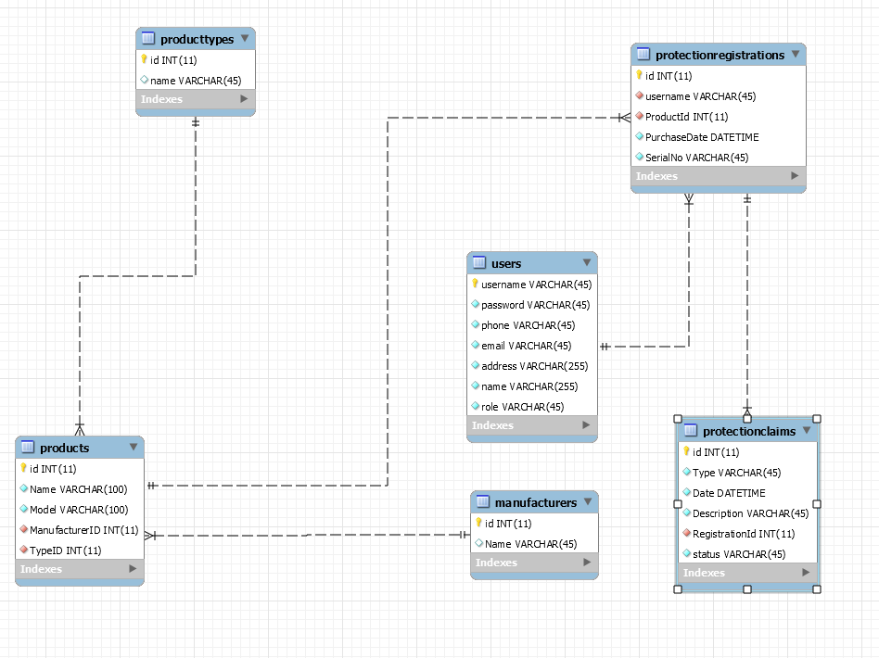

# Section 3 : UI Design (Webforms)

(Show all the webforms and the layout of each webform. Also indicate which table(s) interact with that webform, the validation rules behind each form, and the interconnection between forms )

1. Register form: incase if customer has the account , customer can click on the login link
   1. Tables interact with this webform: users table.
   2. Default role for new account is user.
   3. Username is unique if there is existed username in table user validation message will be shown.

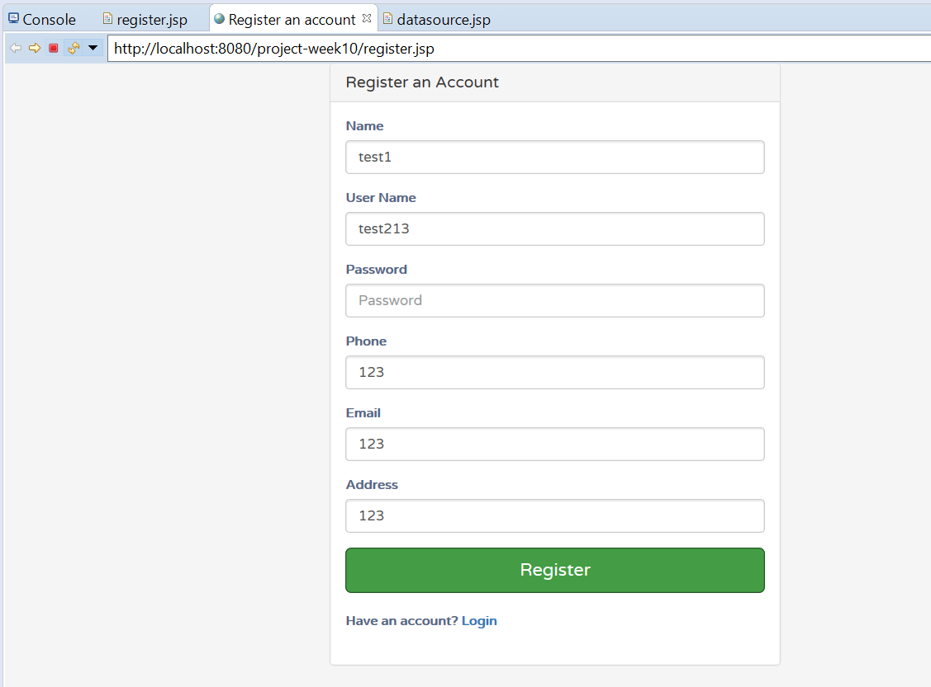

1. Redirect to login form after registered user successfully

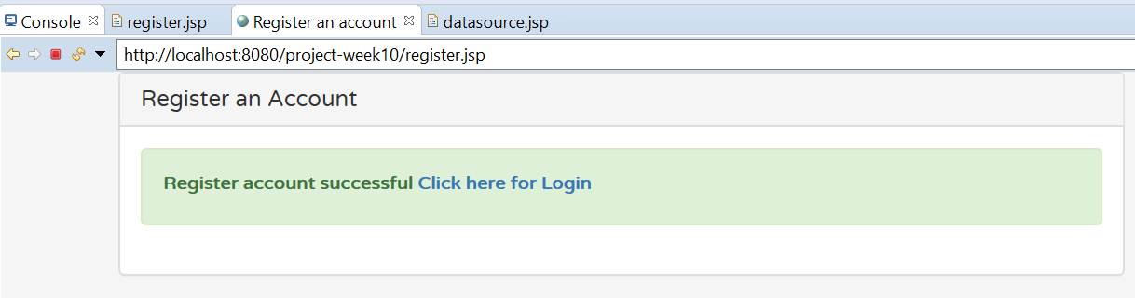

1. Login form
   1. Tables interact with this webform: users table.
   2. Based on the username and password which validate by login.jsp. login user will be assigned permission by authorization.jsp
   3. If input wrong username or password, validation message will be shown.

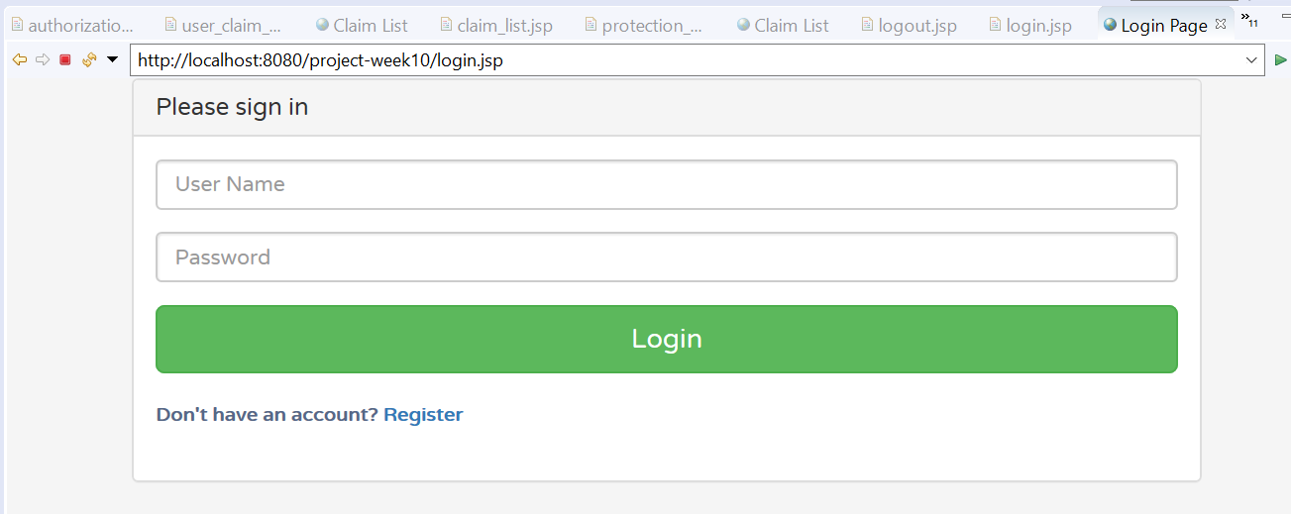

1. Home page of user is the registered product
   1. This form interact with: product, manufacturer and producttype table
   2. The search rule and display the registered product is implemented by protection_list.jsp

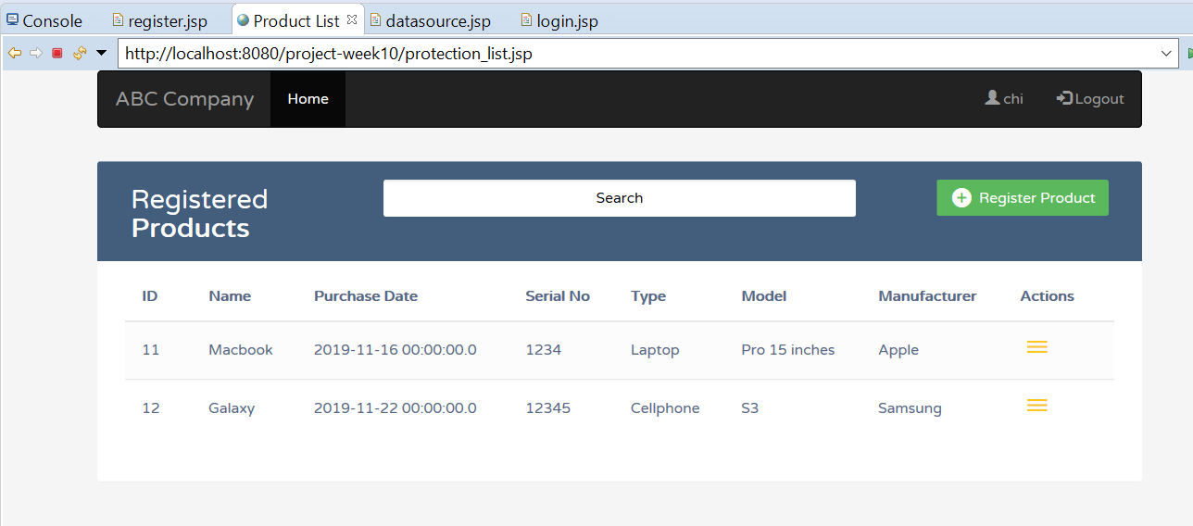

1. Register product form
   1. This form interaction with projectregistrations table
   2. protection_registration.jsp is used to add new product for user and distinguish user by username
   3. User is navigated to protection_list if the product is registered successfully.

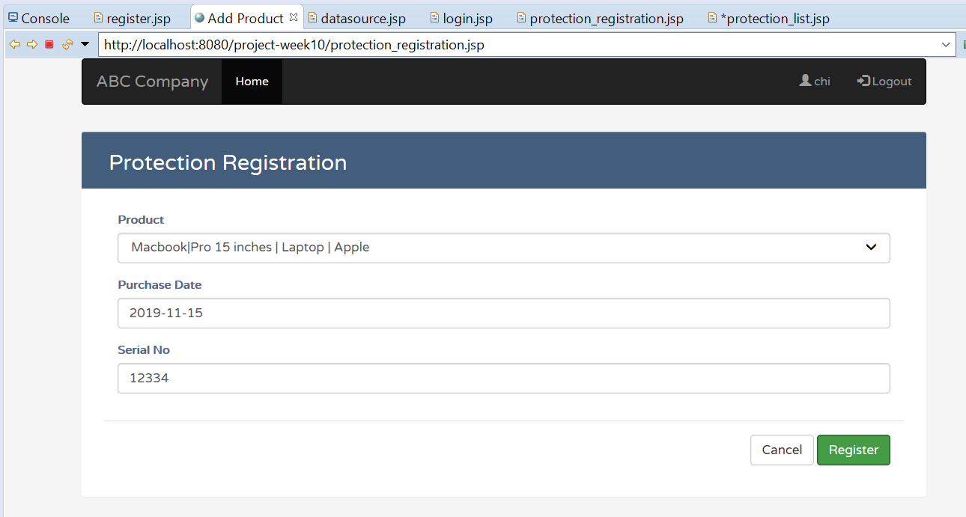

1. List claim of current login user
   1. By clicking on action icon on protection_list page
   2. This form interact with claims table
   3. The list of claim of user is implemented by user_claim_list.jsp

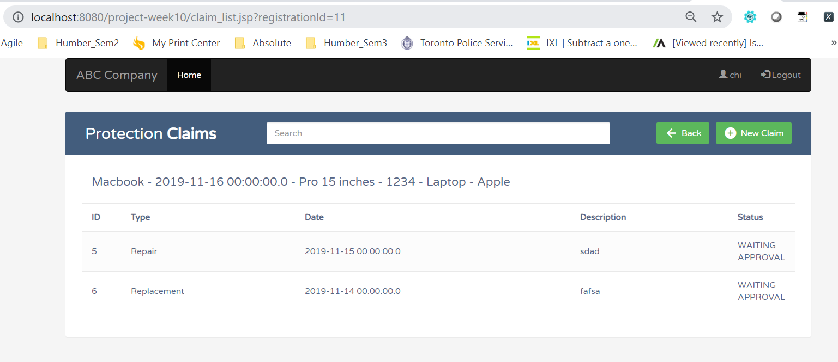

1. Registration new claim
   1. User click on new claim button to add new claim
   2. This interact with claim table
   3. Projection_claim.jsp is used to add new claim

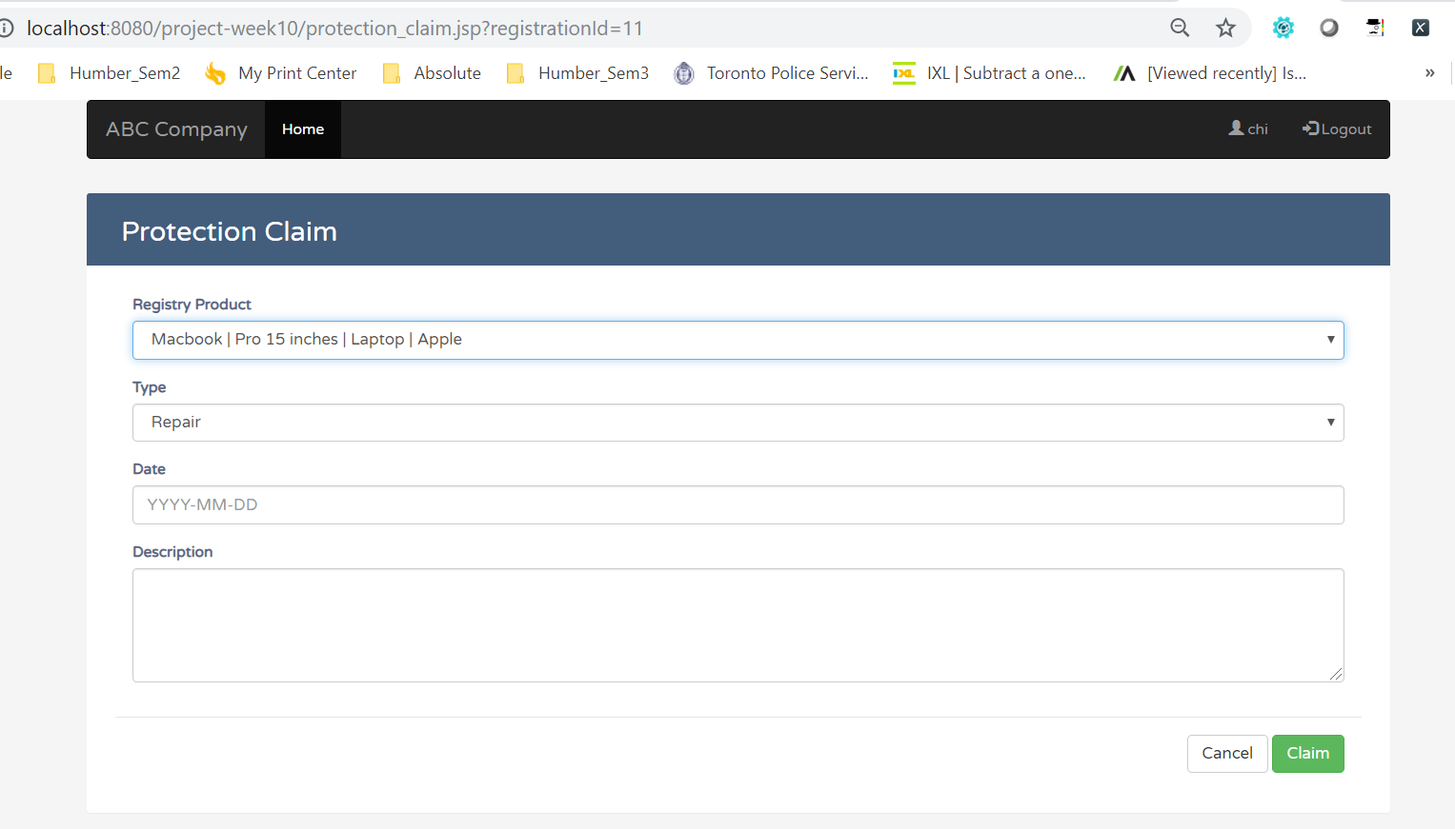

1. Admin home page is manage product page
   1. This form interact with: product, manufacturer and producttype table
   2. The search rule and display the registered product is implemented by protection_list.jsp
   3. Admin can edit and delete new product. This is also implemented by protection_list.jsp

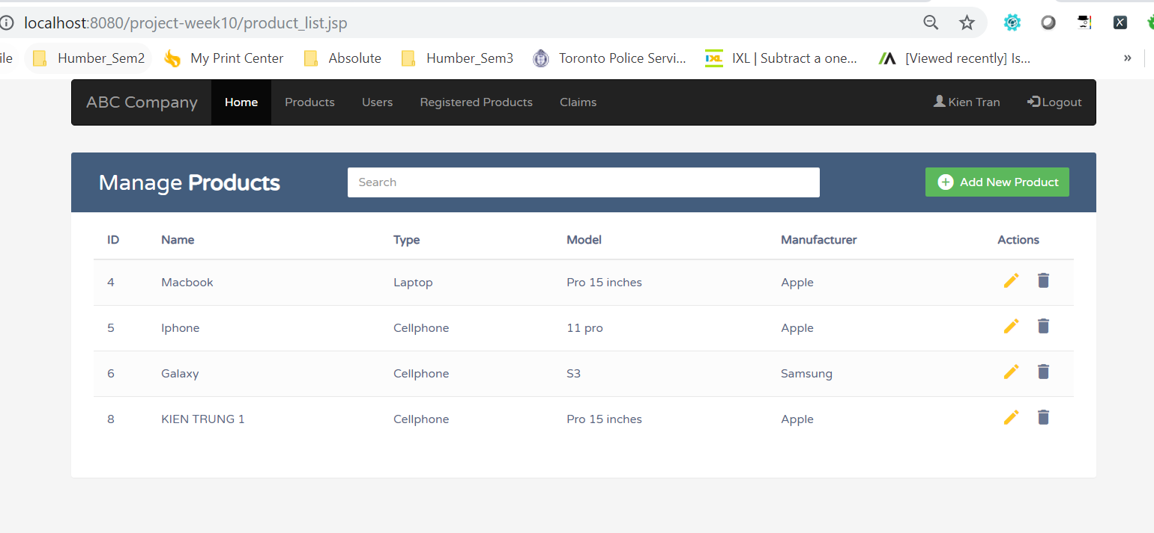

1. Admin add new product
   1. This form interacts with product table
   2. The rule is implemented by add_product.jsp

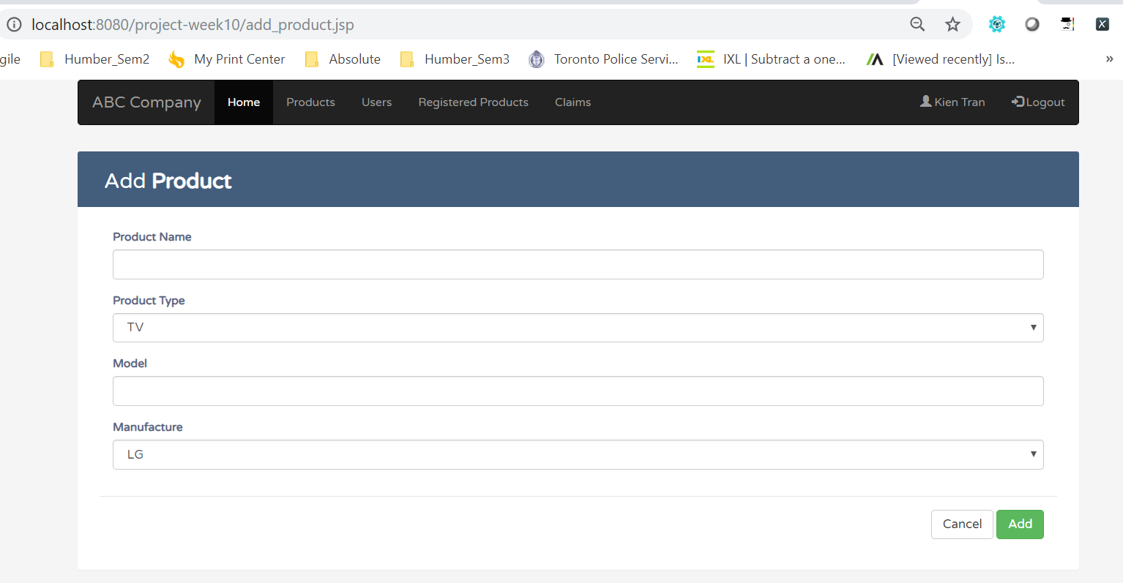

1. List all users form
   1. This form interacts with users table
   2. This is implemented by user_list.jsp
   3. Search function is also built in this page.

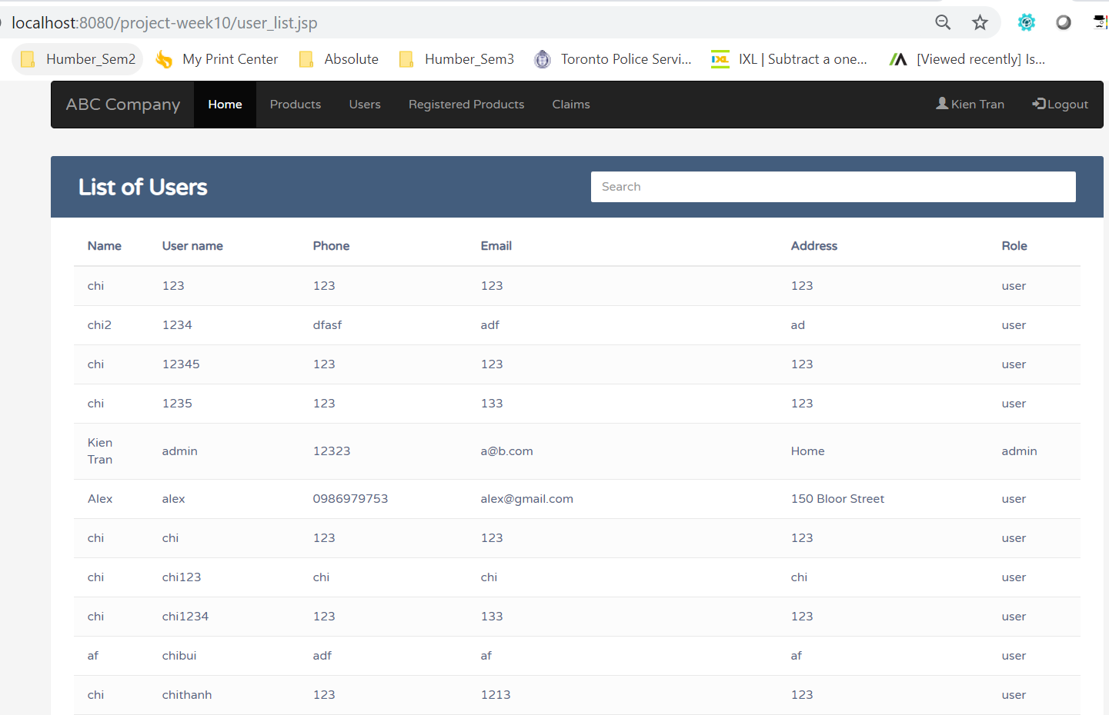

1. List all registered product
   1. This form interacts with users, product, producttype, manufactures table
   2. The rule is implemented by registered_product_list.jsp
   3. Search function is also built in this page.

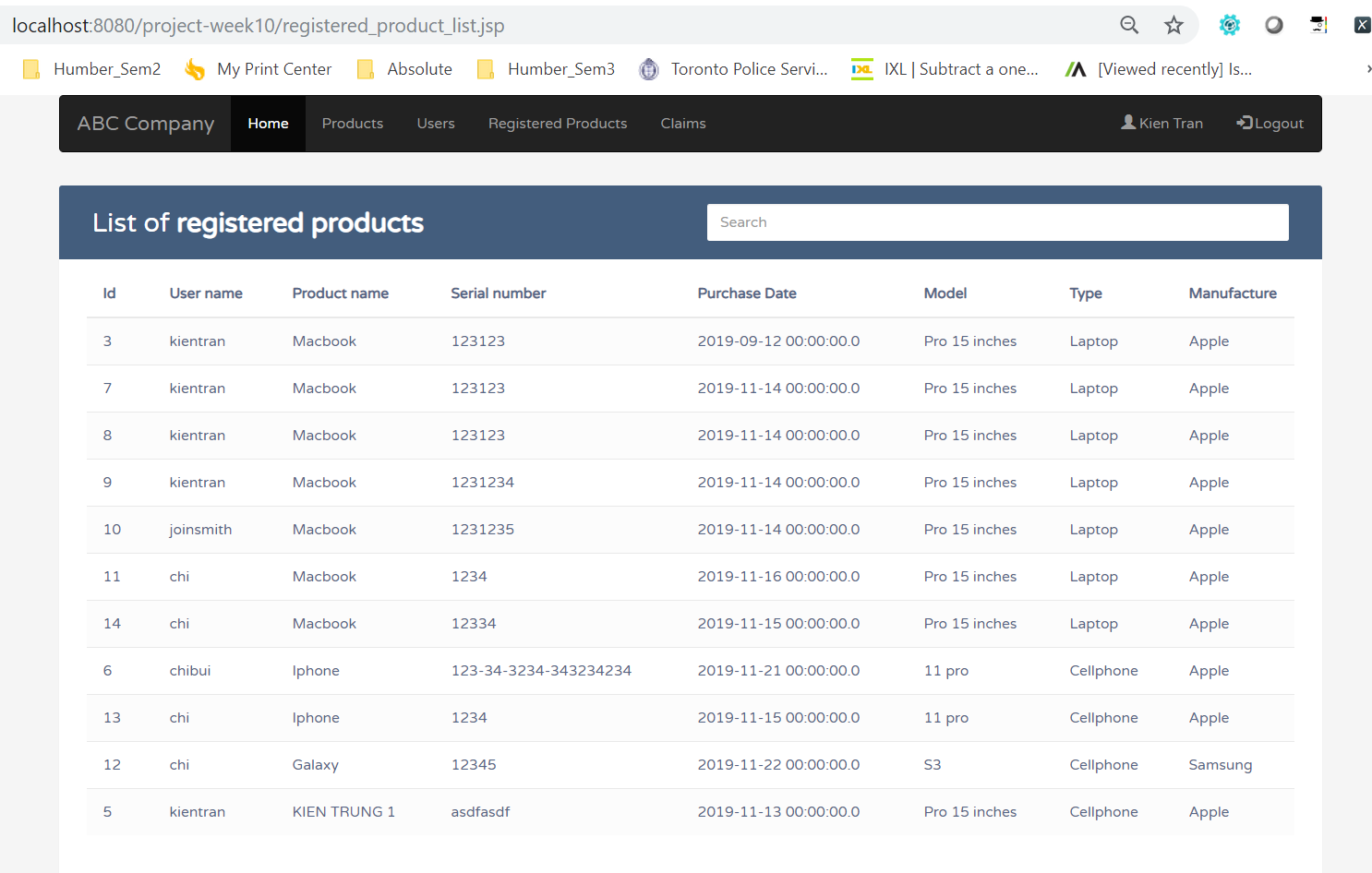

1. List all claims
   1. This form interacts with protectionclaims table
   2. The rule is implemented by user_claim_list.jsp
   3. Approve claim action is executed under Action colum and implemented by approved_claim.jsp
   4. Search for claim is also built in function of this jsp file.

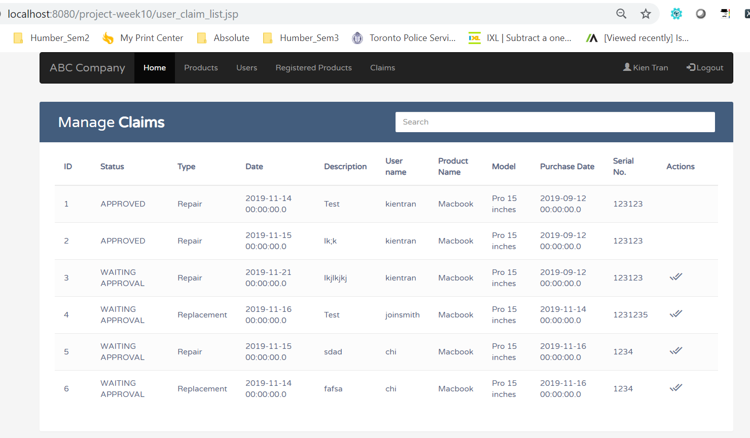

# Section 4 : JSP/JSTL codings

(Describe each JSP pages that you design including the file-name, the main functionalities of each JSP page. Explain (1) Error Handling (2) Manage CRUD operations (3) Control Login/Access level – *Don’t copy/paste the whole coding here*, *just the simple explanation of main building block in each JSP file*)

1. The common rule for error handling is catch the exception return from the database. If there is exception then handle the exception by redirect to the same page and display error message.

2. For CRUD: Based on the value passing from the from. We filter the GET (update/delete/modify) or POST (create new) method and handle in one JSP file

3. For control login and access level we use the <%@ include file="common/authorization.jsp" %> for all the page to set the permission and the role attribute of Users to distinguish between admin and user.

## 1 authorization.jsp

Declare a map and set the string array value (pages) for user and admin.

Map<String, String[]> resourcePermission = **new** HashMap<String, String[]>();

//Define the list of resource that user who has admin role can access

resourcePermission.put("admin", **new** String[] { "home","product_list", "add_product", "delete_product", "user_list","user_claim_list","approve_claim","registered_product_list" });

//Define the list of resource that user who has user role can access

resourcePermission.put("user", **new** String[] { "protection_registration", "protection_list",

"protection_claim", "claim_list", "protection_claim", "protection_claim", "protection_claim", });

//Get login user information from session object

String username = (String) session.getAttribute("username");

String role = (String) session.getAttribute("role");

//If user is not login then redirect the user to login page

**if** (username == **null** || username.isEmpty()) {

response.sendRedirect("login.jsp");

} **else** {

//Get the granted resource for the role which current user belong to

}

## 2 datasource.jsp

Set the data connection and data source

## 3. add_product.jsp

* Filter the post method by: <c:if test="${pageContext.request.method=='POST'}">
* If the id is not empty then update the product <c:when test="${!empty param.id}"> then go back to product list page.
* Otherwise add new product into product table and go back to the product_list page
* Filter the get method by: <c:if test="${pageContext.request.method=='GET'}"> means user redirect from the Add producct the page
  + If id is not empty <c:if test="${ !empty param.id}">: check if produc is existed in the database and return the product into data variable

<c:set var=*"data"* value =*"*${exitingProduct.rows[0]}*"*/>

* Show the <h2> Add product or update product based on param.id . If param.id is not empty show update else show add product

<c:when test=*"*${!**empty** param.id}*"*> Update <b>Product</b>

</c:when>

<c:otherwise>

Add <b>Product</b>

</c:otherwise>

* For the form is set by param.id. If param.id is not null show the update product form else show the add product form

## 4. approve_claim.jsp

* if <c:if test="${ empty param.claim_id}"> then navigate to <c:redirect url="user_claim_list.jsp">
* else approve the claim based on the claim_id
* if the claim is found then update the status and catch the exception

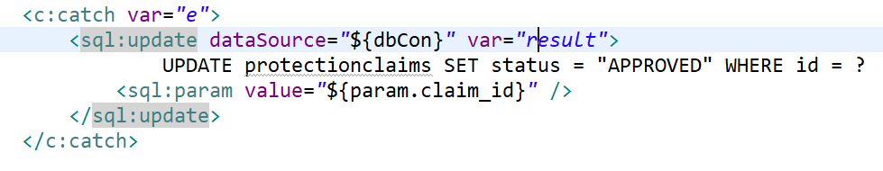

* if the exception is not null then show error otherwise set the successful message and redirect to user_claim_list.jsp

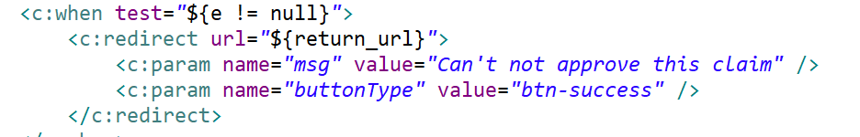

## 5. claim_list.jsp

* Show all the registration claim when there is no seach value

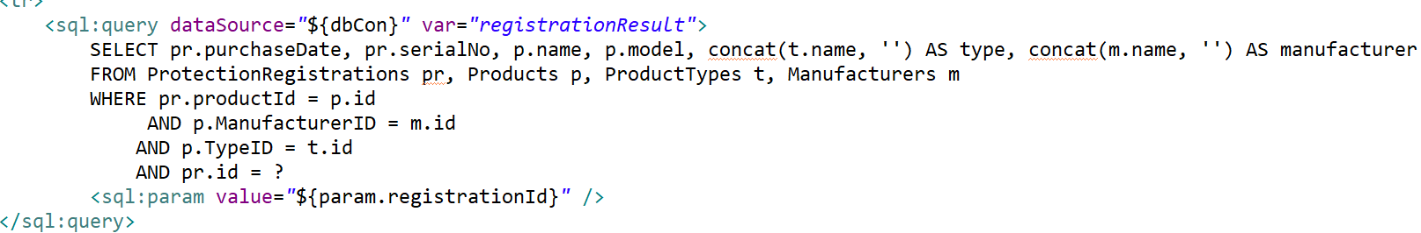

* Show the result for the search claim

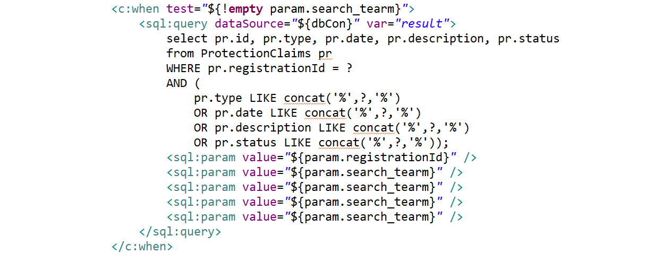

## 6. delete_product.jsp

Based on the param.id passing from product_list.jsp and select the product for delete and catch the exception if there is no product existed

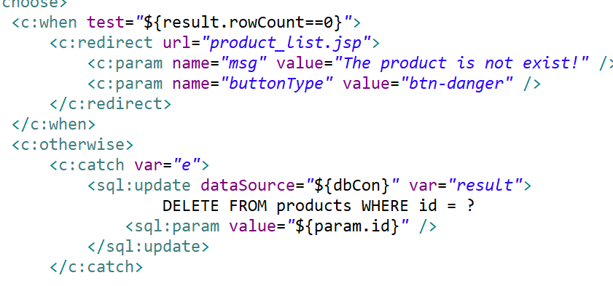

## 7. home.jsp

* Show all the waiting approval claim of user for Admin

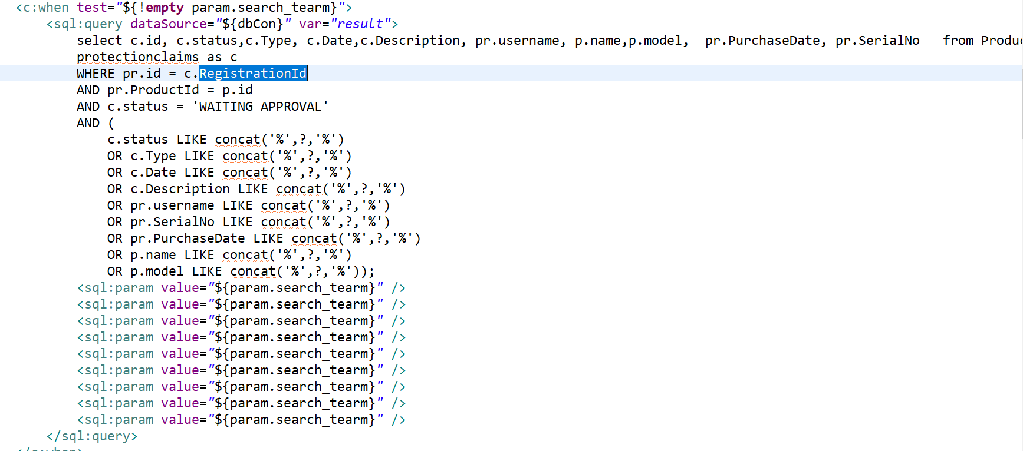

* Approve for claim

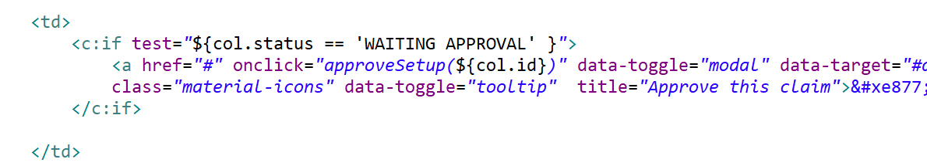

## 8. login.jsp

* Determine the home page for admin or protection_list.jsp page base on the role of login account

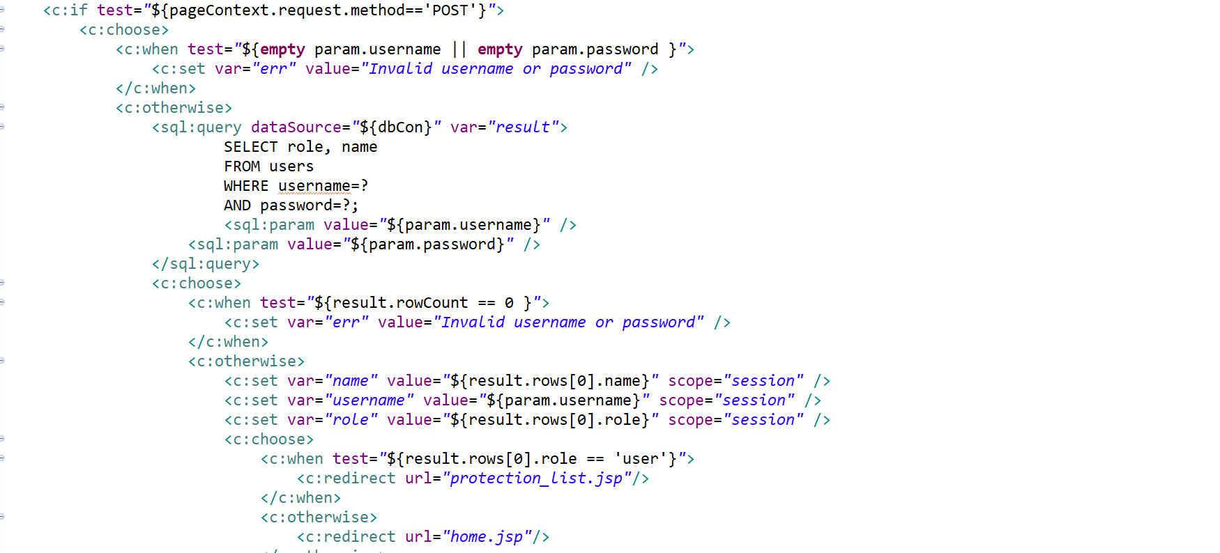

## 9. logout.jsp

* Clear all the session information

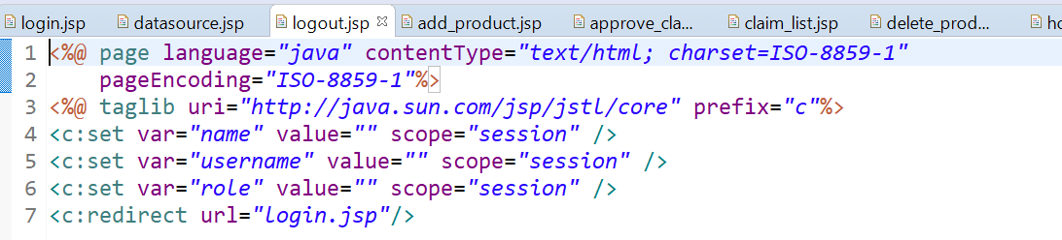

## 10. page_not_found.jsp

* If user does not have the right to access the page. This page will show

## 11. product_list.jsp

* List all the product for Admin to manage. Query the data and return the result into the result variable and for the search then show on the page.
* Edit and delete product is handle by add_product.jsp by passing the param col.id

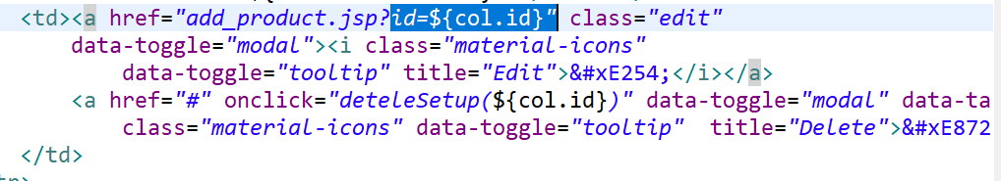

## 12. protection_claim.jsp

* Show the submitted claim of each login user or add or new claim

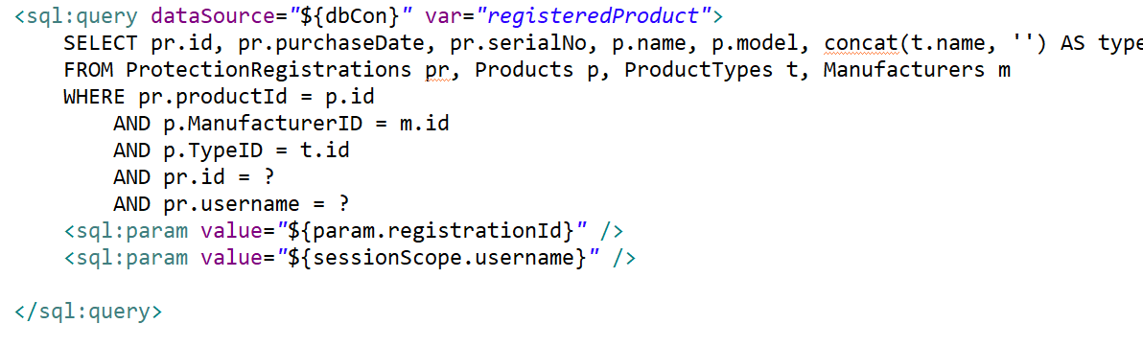

## 13. protection_list.jsp

* Show all the claim and also the search result based the <c:when test="${!empty param.search_tearm}"> condition

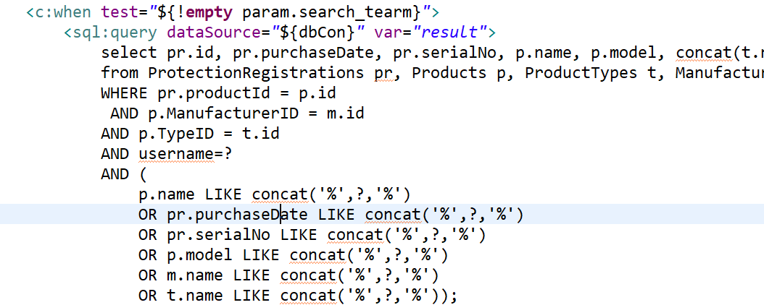

## 14. protection_registration.jsp

* User register new product

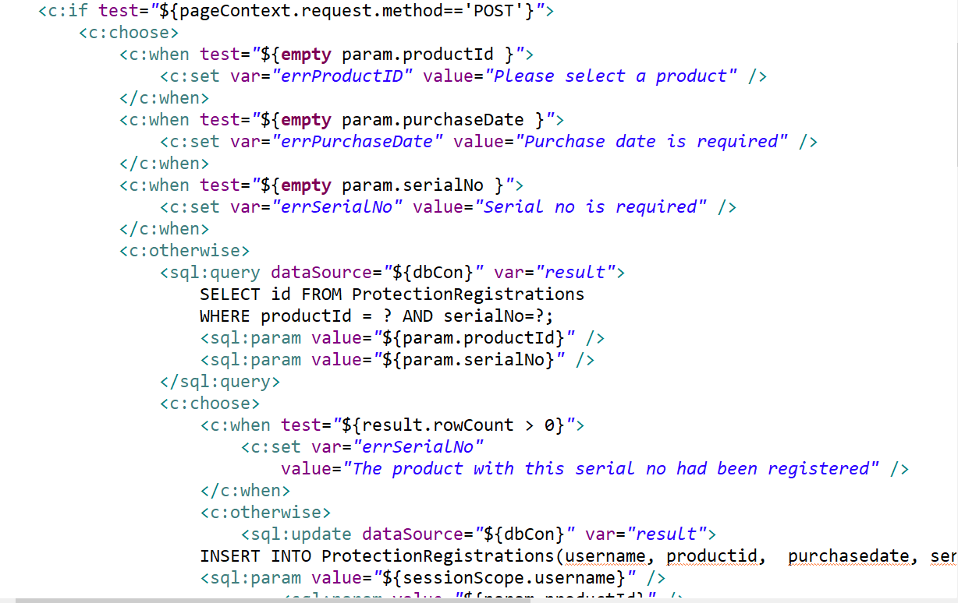

* Show all the registered product of users and the search result

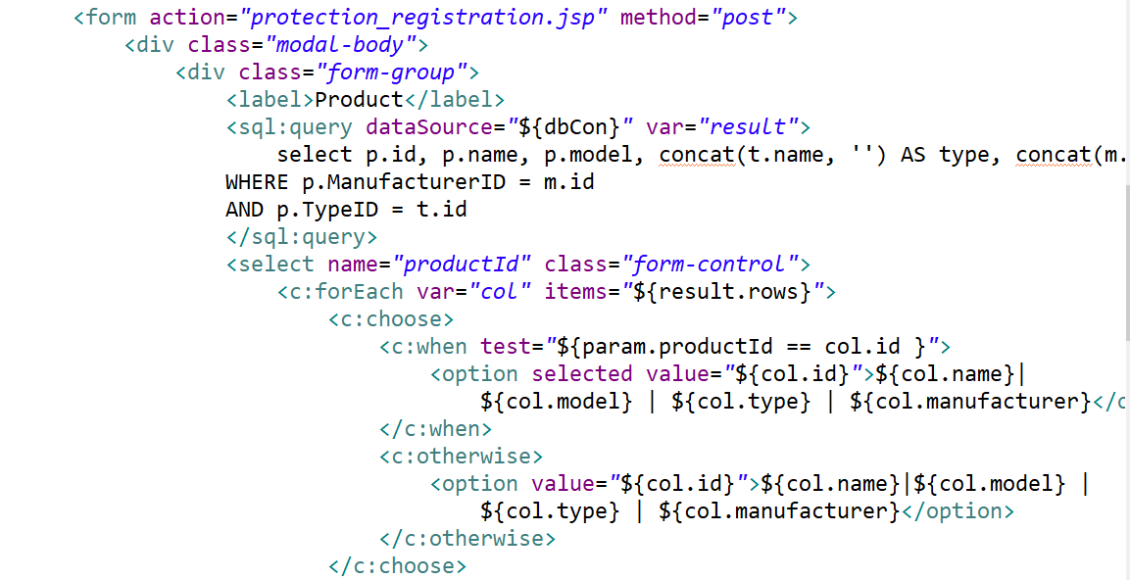

## 15. register.jsp

Register new user, if user existed then there is error message.

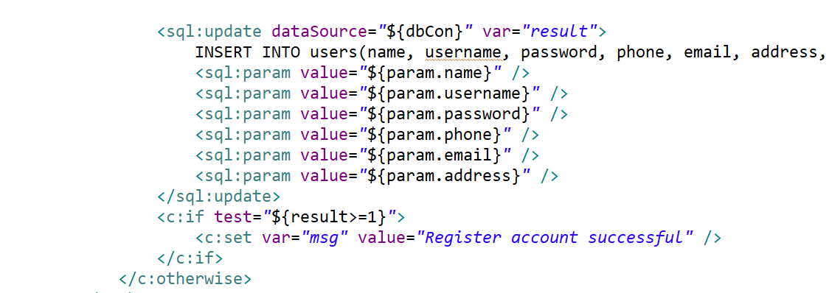

## 16. registered_product_list.jsp

* List all registered product of user, this is for admin

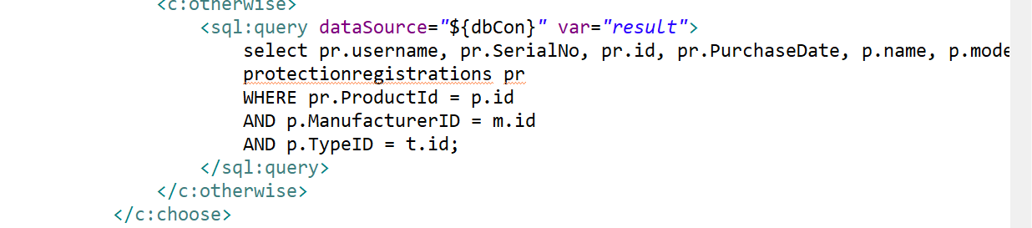

## 17. user_claim_list.jsp

* List all claim in the system, this is for admin

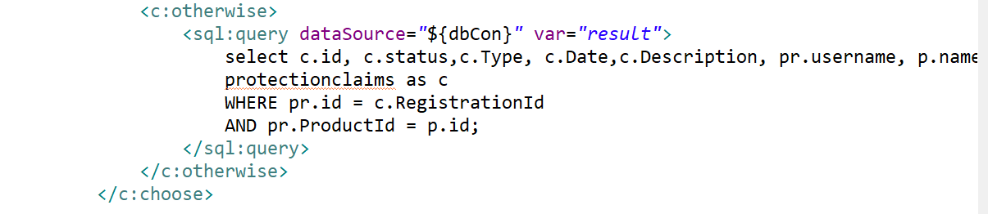

## 18. user_list

* List all the user in the system, this is for admin

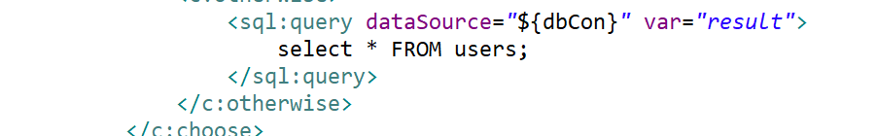

# Section 5 : New functionality

(Describe the new functionality that you have added to the web application. How did you come up with the idea, and how did you implement it)

We add the authorization function to the web beside authentication. This function is to make sure that an authenticated user can only access certain resources which granted to the role that user belonging to. For example, normal users are not allowed to access the resources that granted to admin user.

We came up with this idea because we believe that for every application, the security in general or authorization in specific is very important aspect that need to be fulfilled in order to protect information.

We implemented a center authorization function that will be injected in to all resources of the system. When an authenticated user accesses a resource, the authorization function will check whether the role of current user is granted the permission to access that resource or not. If it is not the case, user will be redirect to a specific page.

# Section 6: Program execution/output

(Show how program works -- add some screenshots, from two aspects, ADMIN login, CUSTOMER login )

1. New user register an account

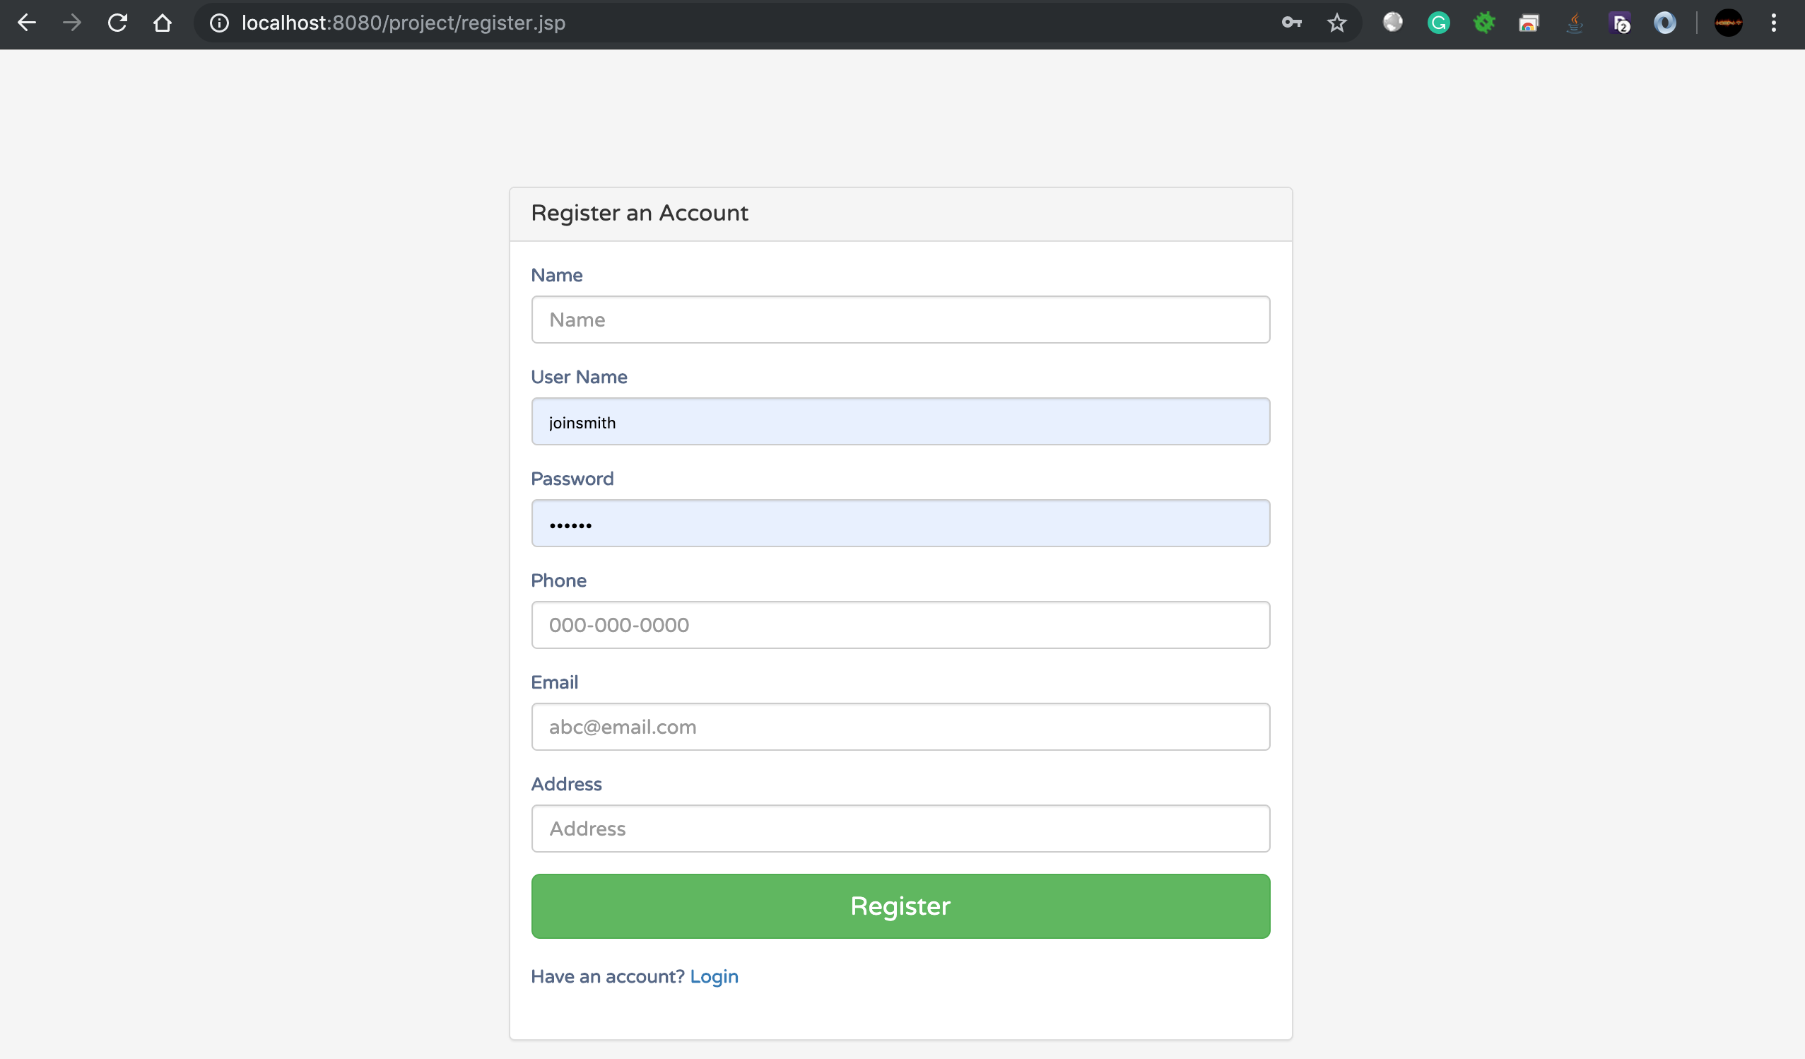

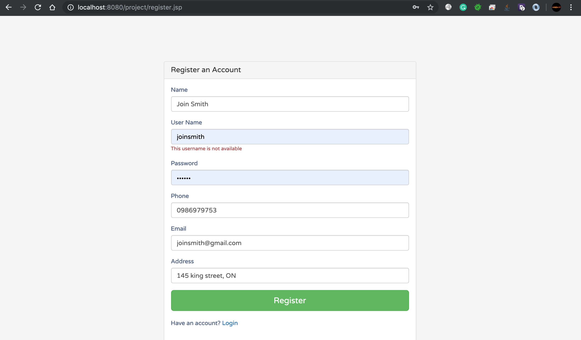

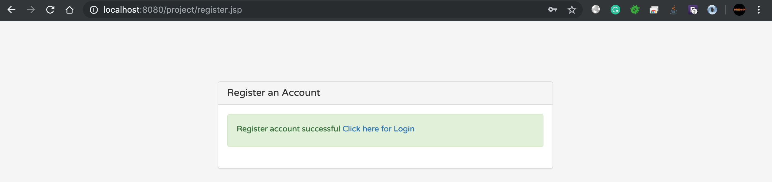

1. User login

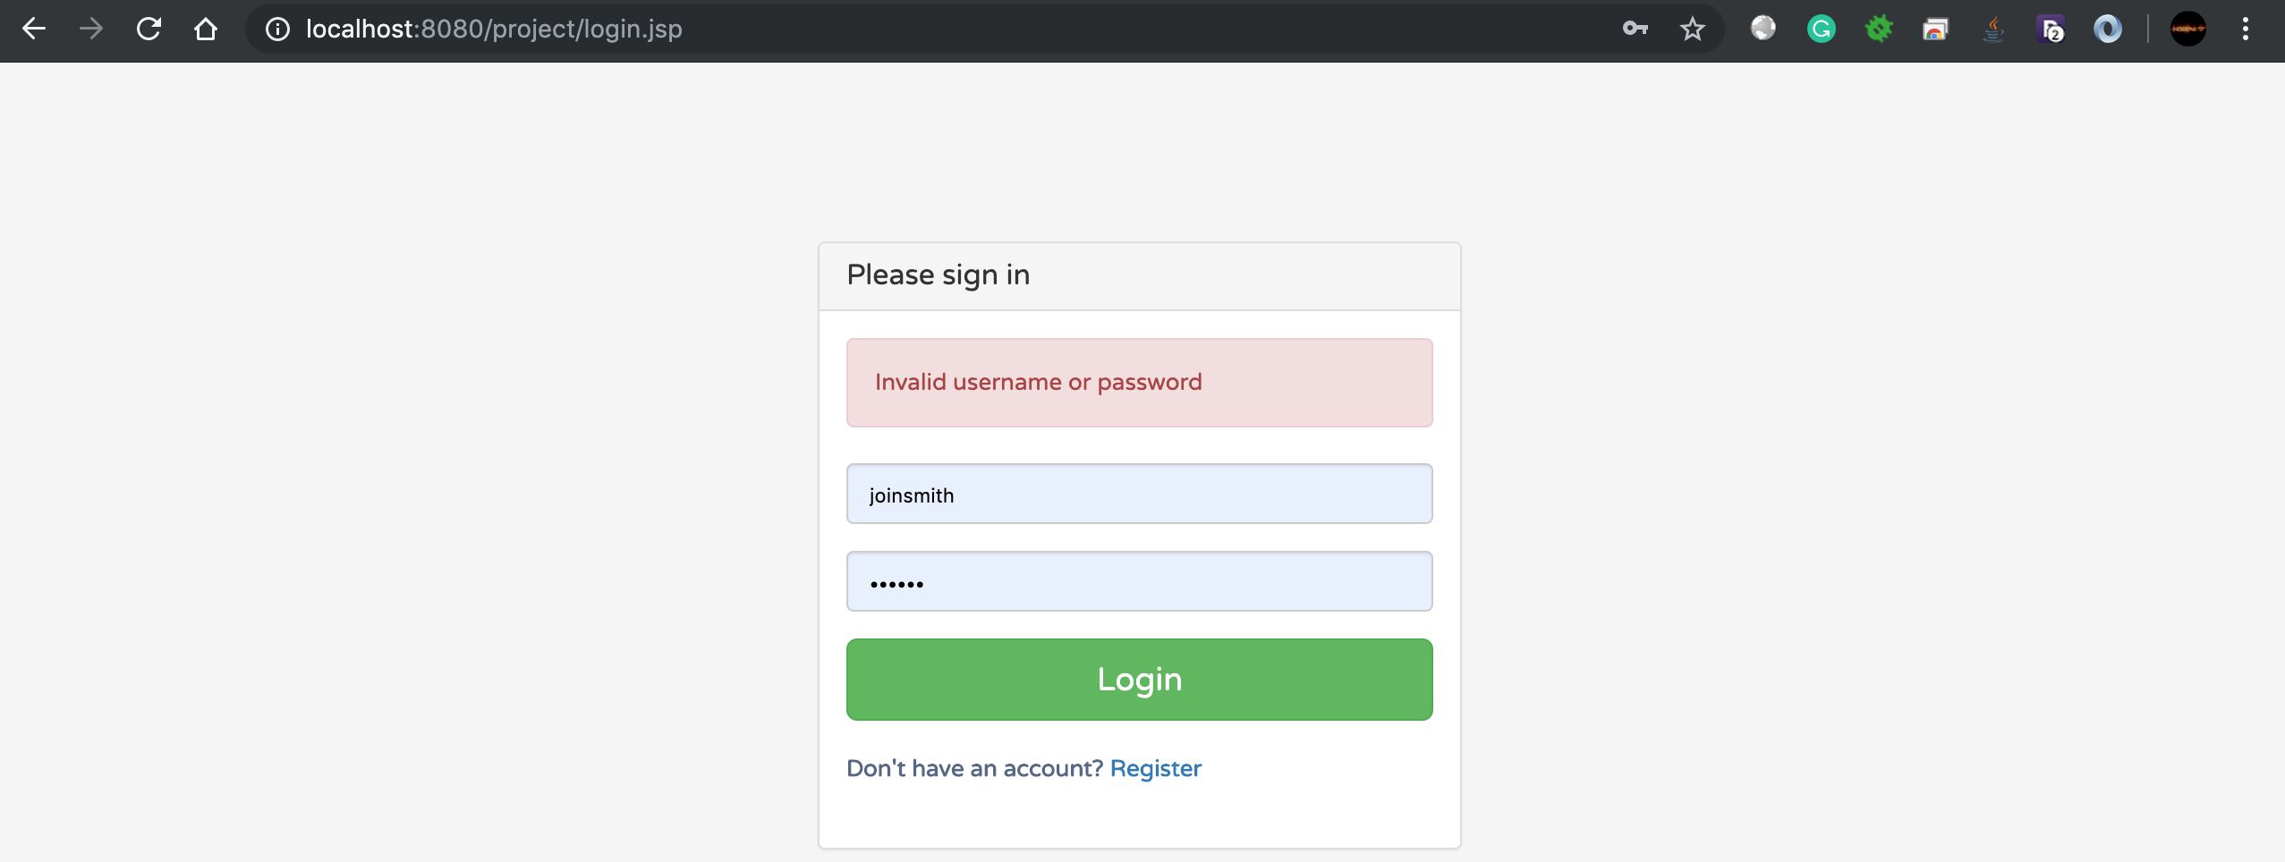

1. Home page of client view which list all registered products of that user. User can search and registered new product

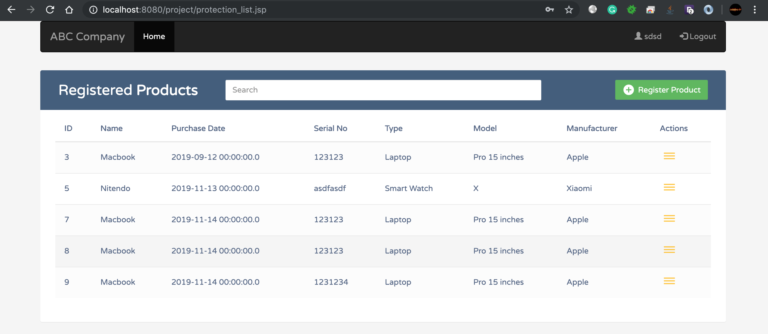

1. User register new product for protection

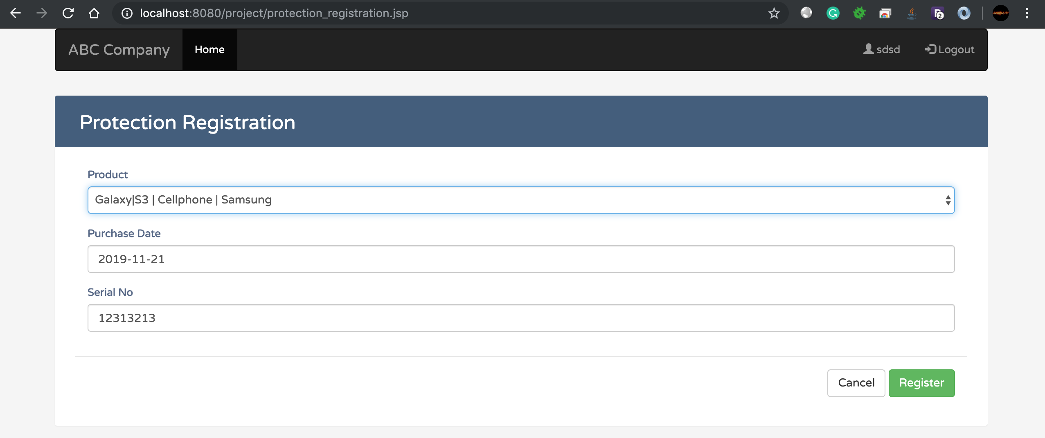

1. Product register successful message

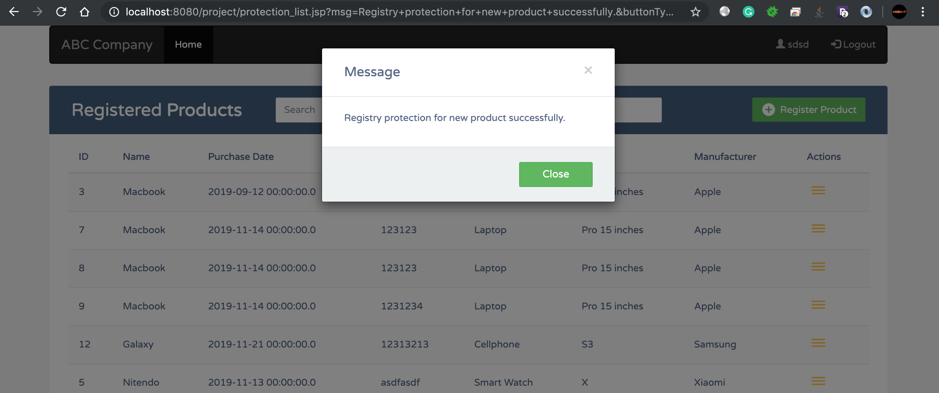

1. When user click on the icon on the left side of each product in the list. User will be navigated to Protection Claims list of that product. In this page, user can view, search all claims or add a new claim for this product

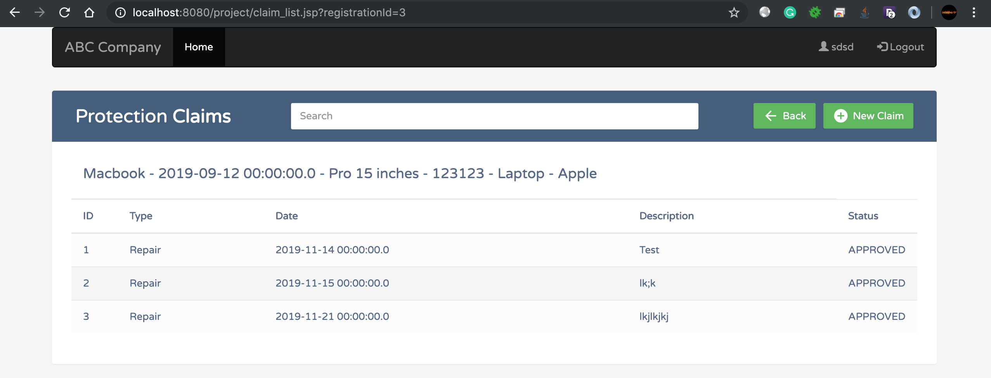

1. User can only claim maximum 3 times within 5 years since purchase date for each product.

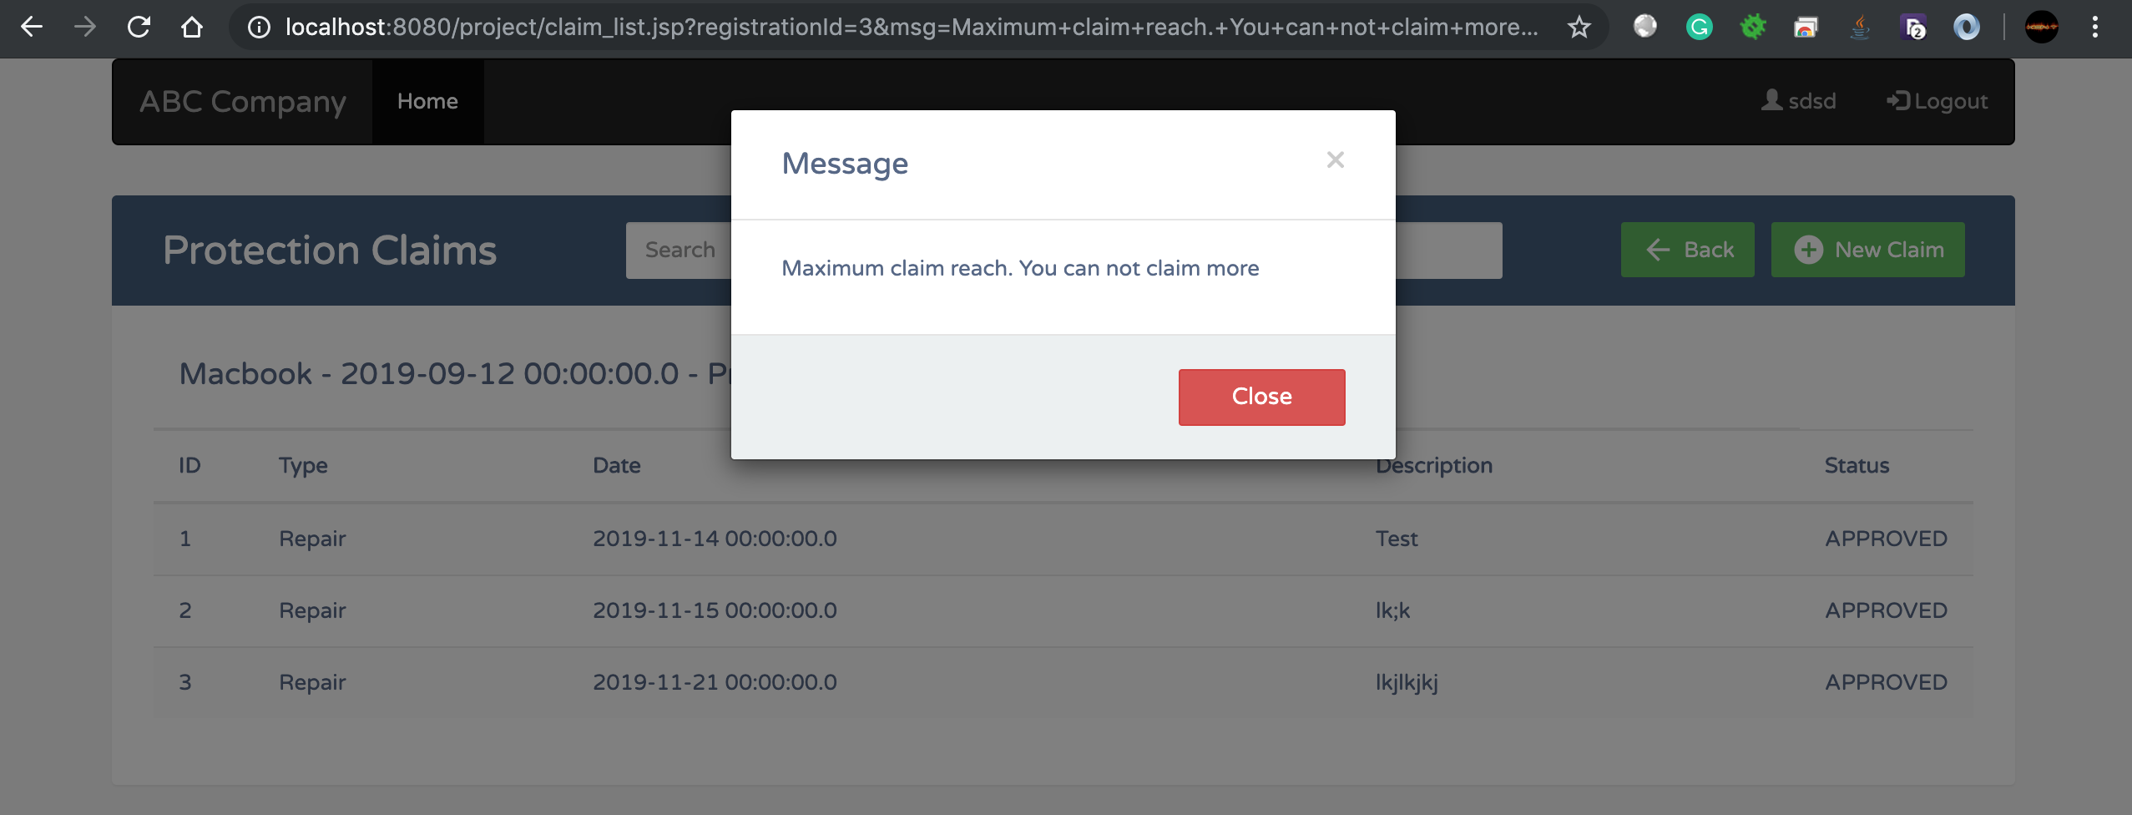

1. User can add a new claim for a product

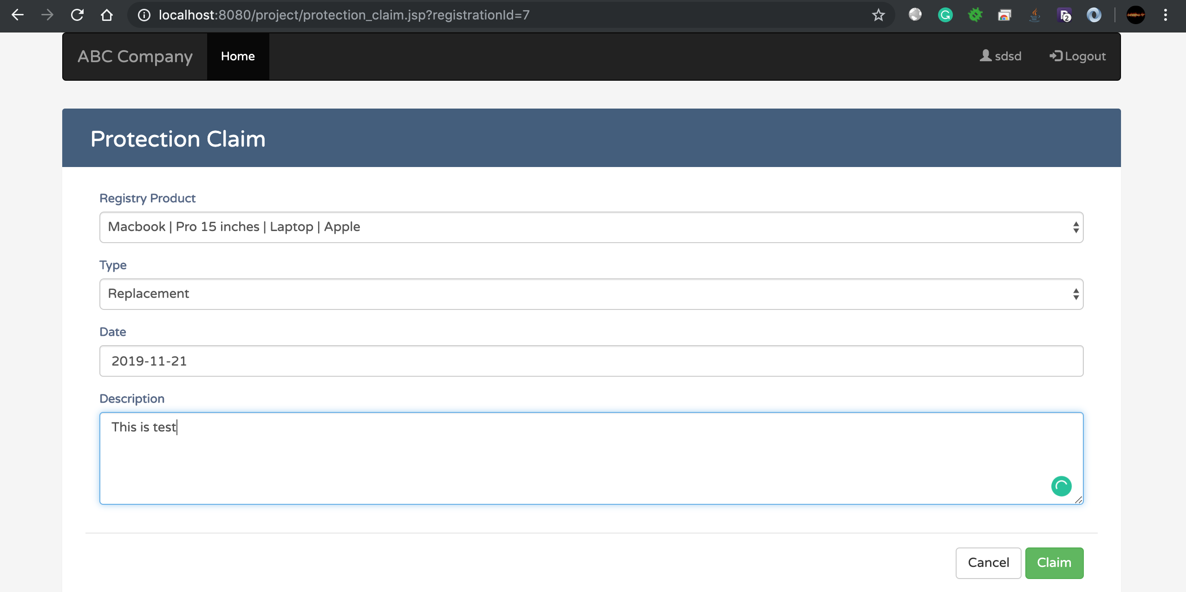

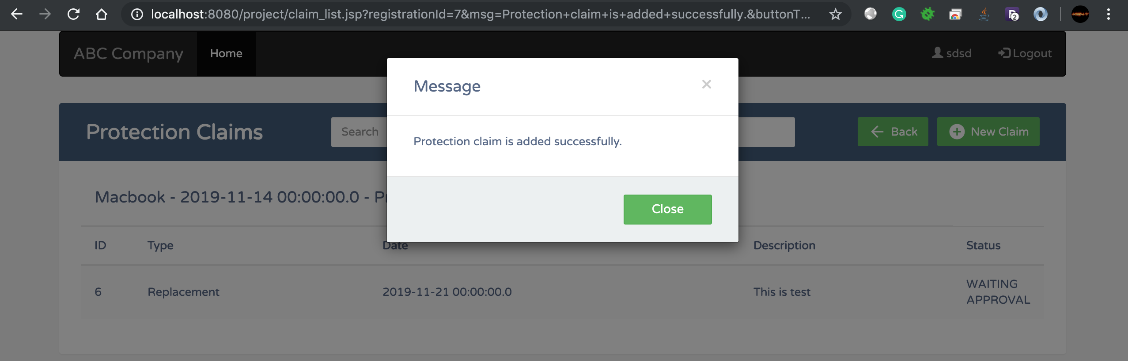

1. Admin login

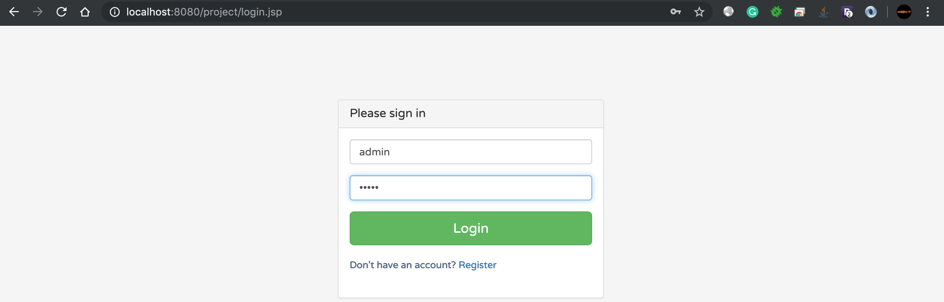

1. Home page of admin will list all claim from users that are waiting for approval

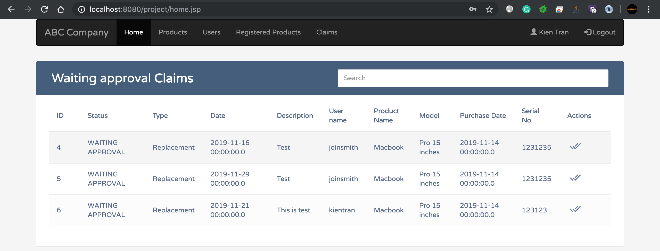

1. Admin can approve for a claim

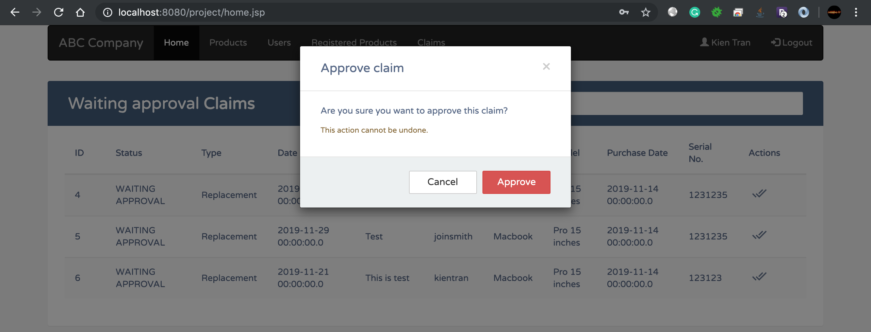

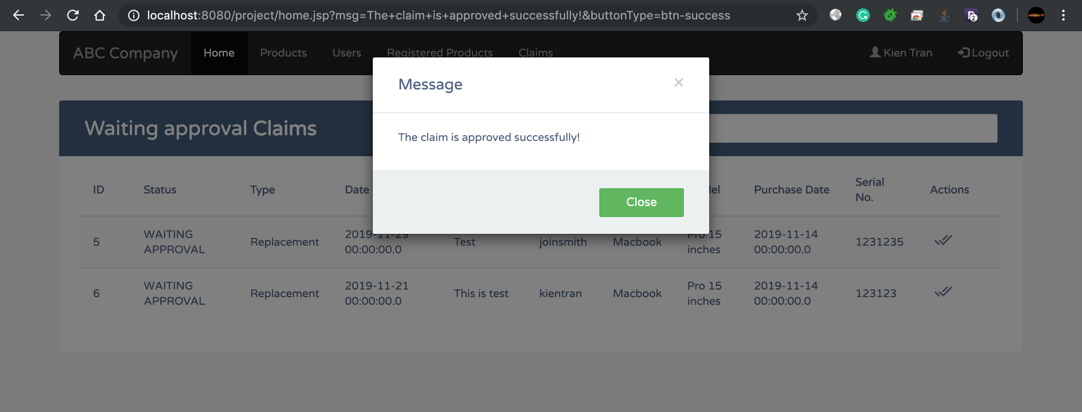

1. Product Management page list all products in the system, admin can search, add, edit or delete the product

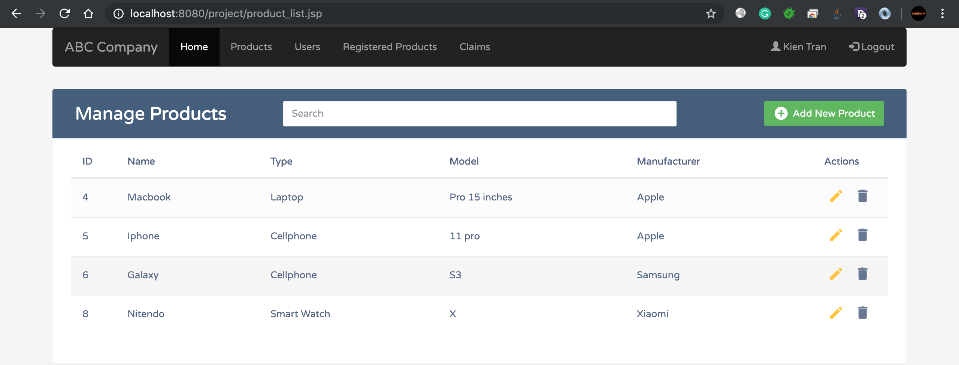

1. Searching a product

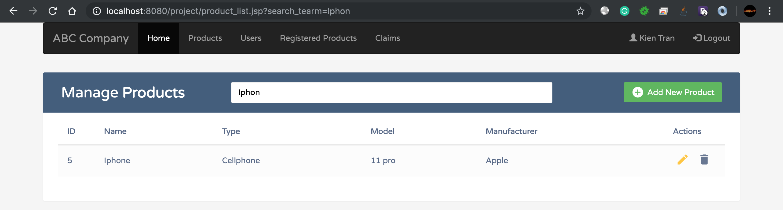

1. Adding a product

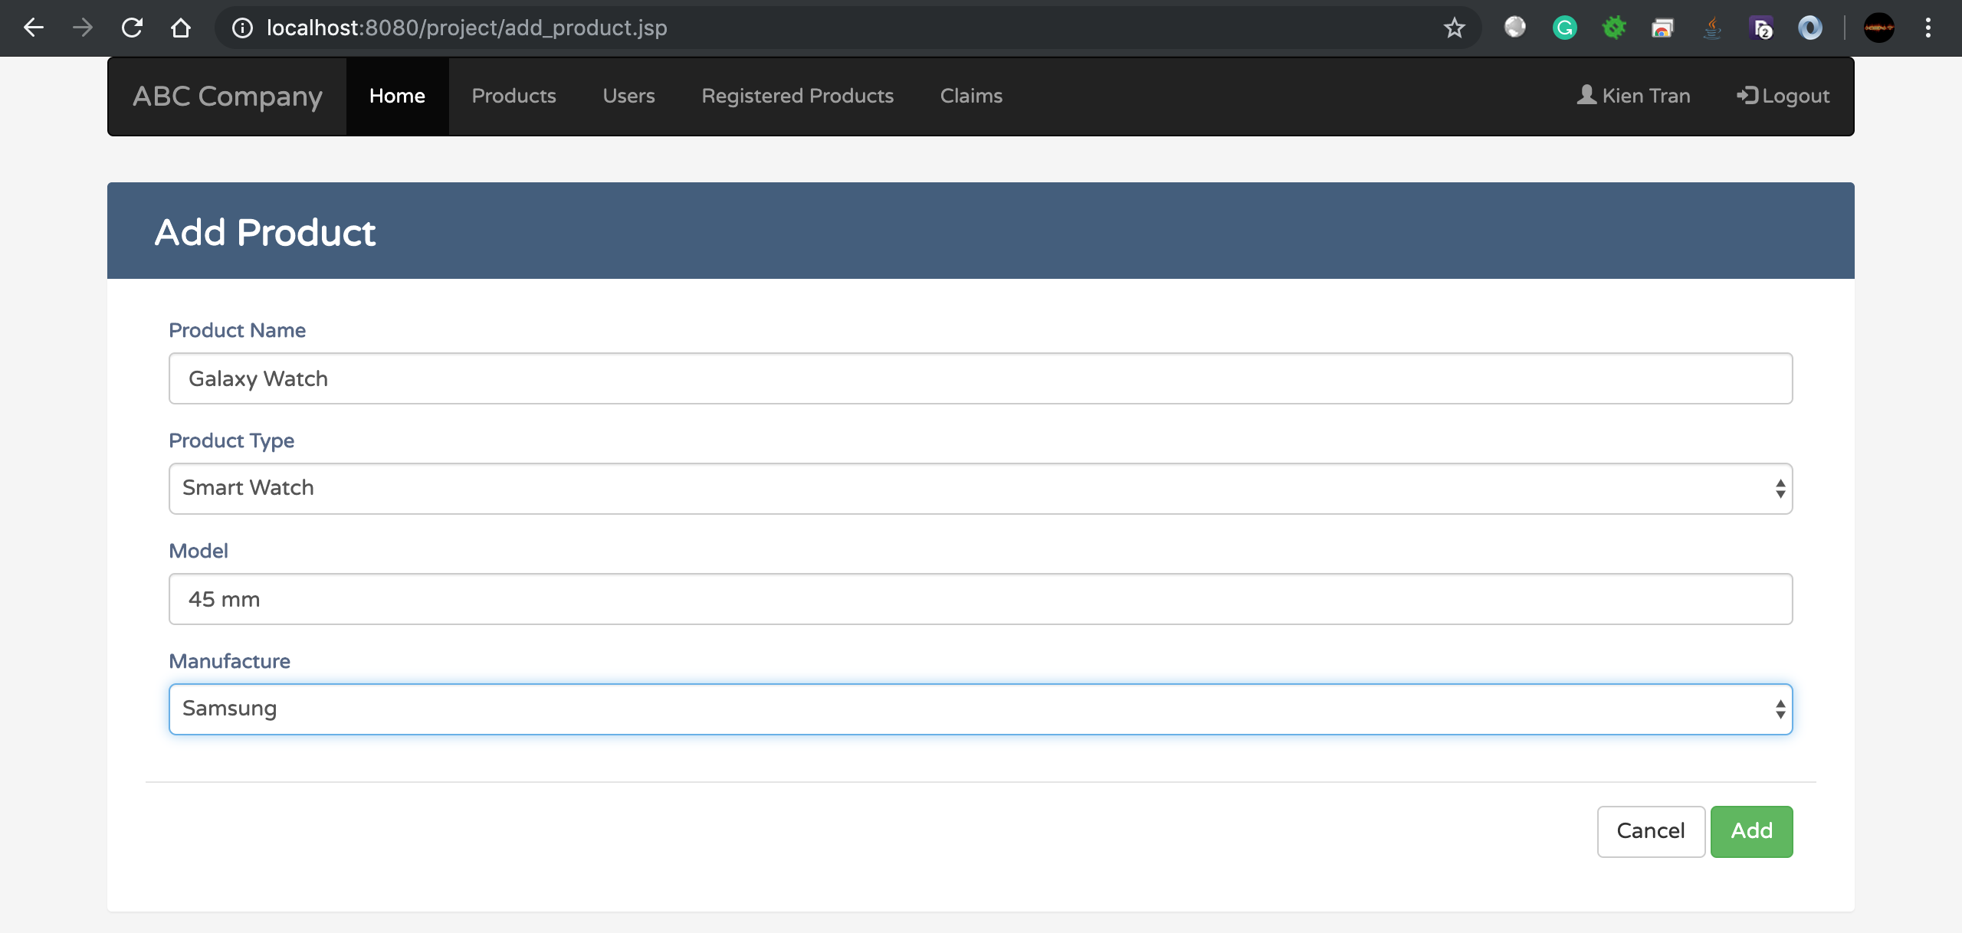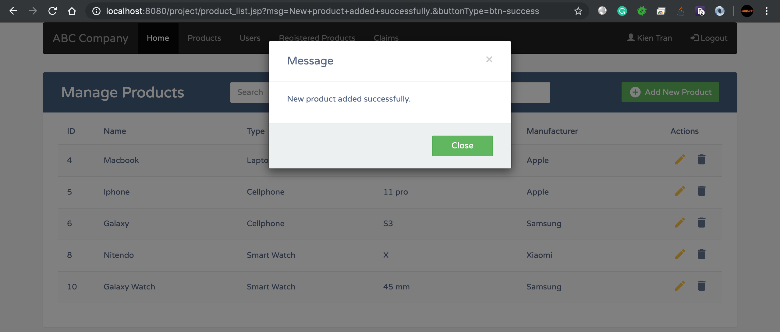

1. Updating a product

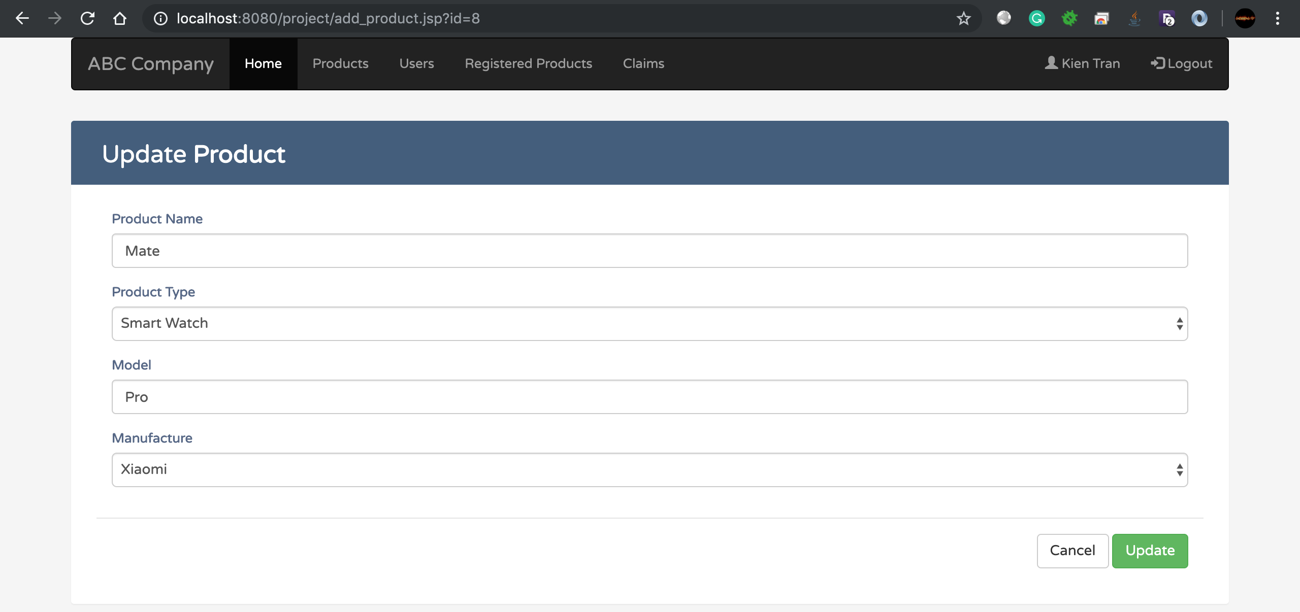

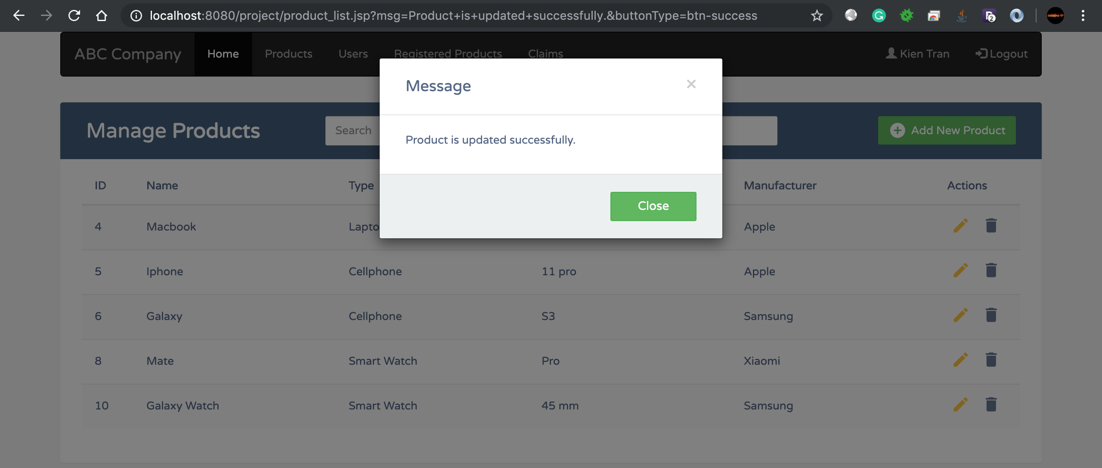

1. Deleting a product

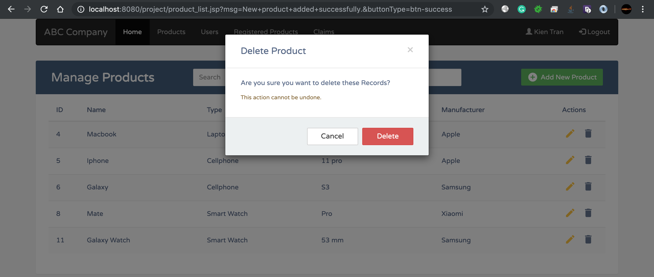

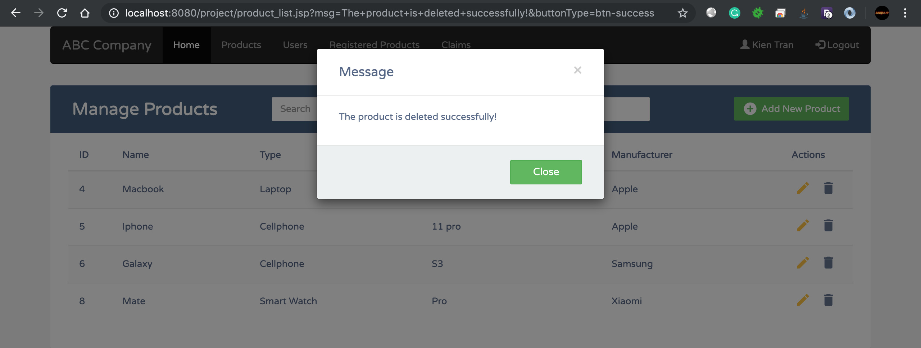

1. Admin can view a list of users and searching on that list

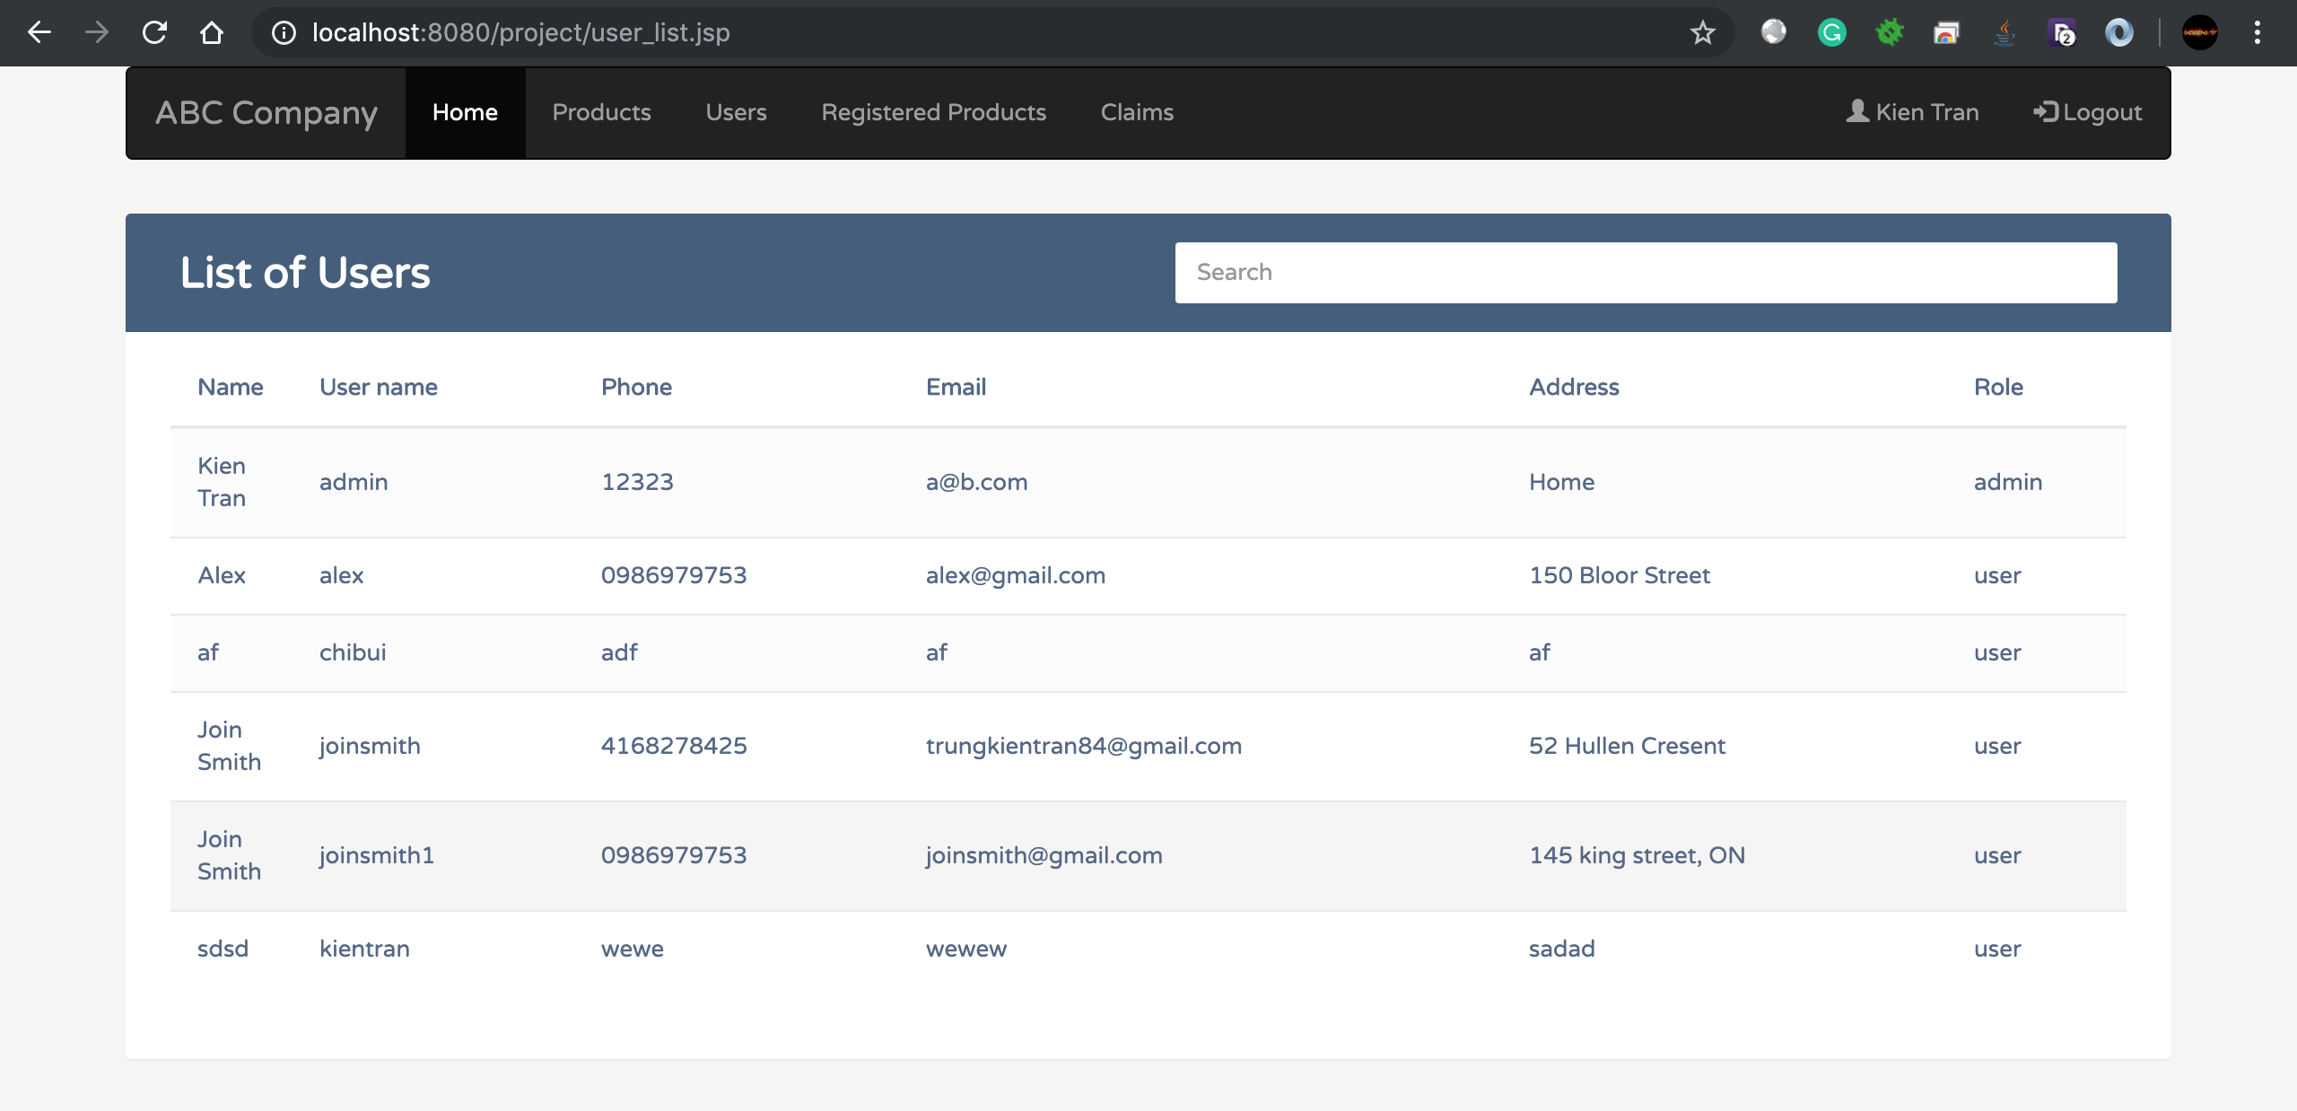

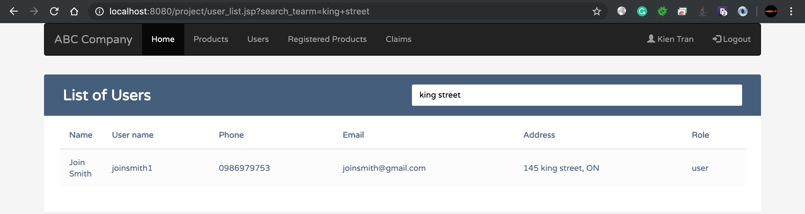

1. Admin can view a list of registered products and search in that list

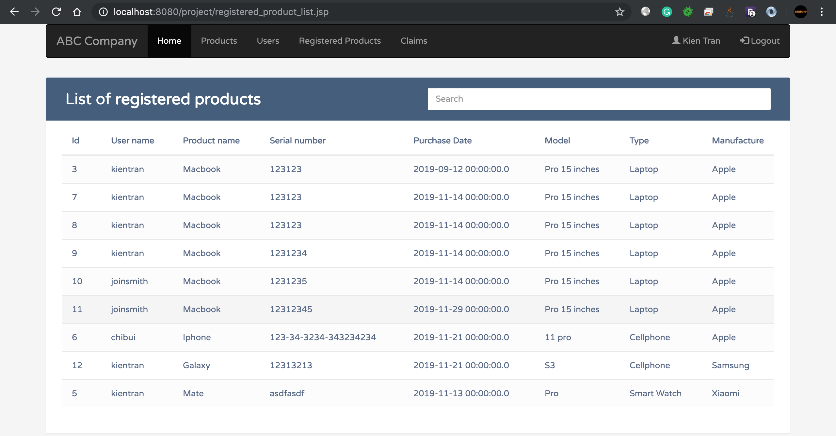

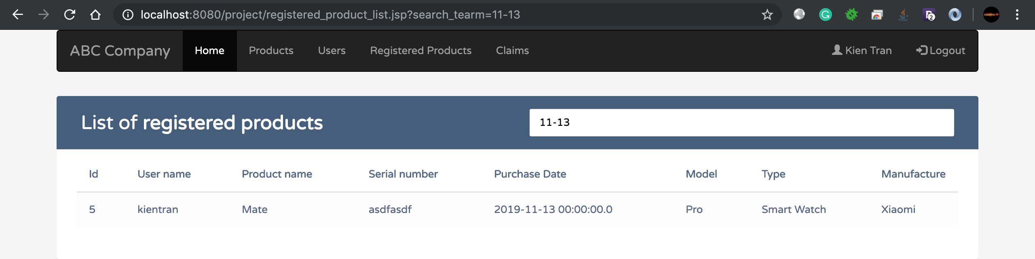

1. Admin can view a list of all claims, searching on the list and approve for waiting approval claims

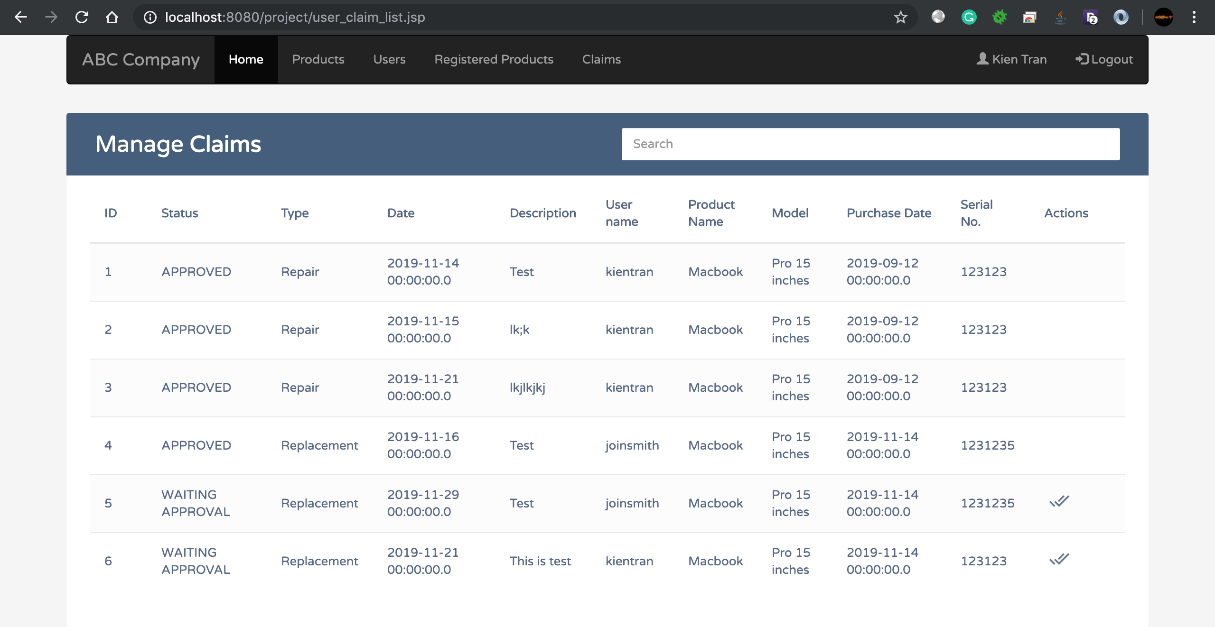

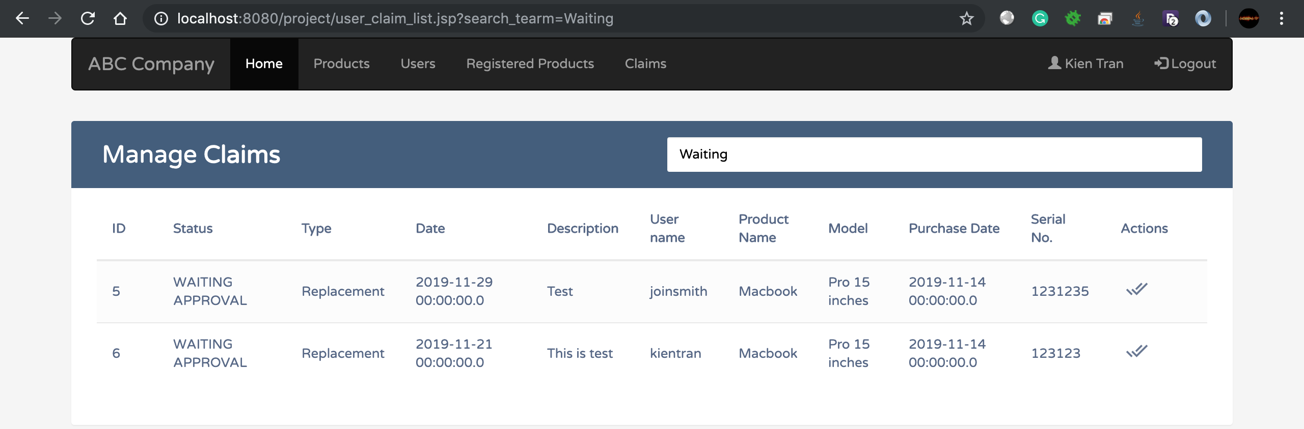

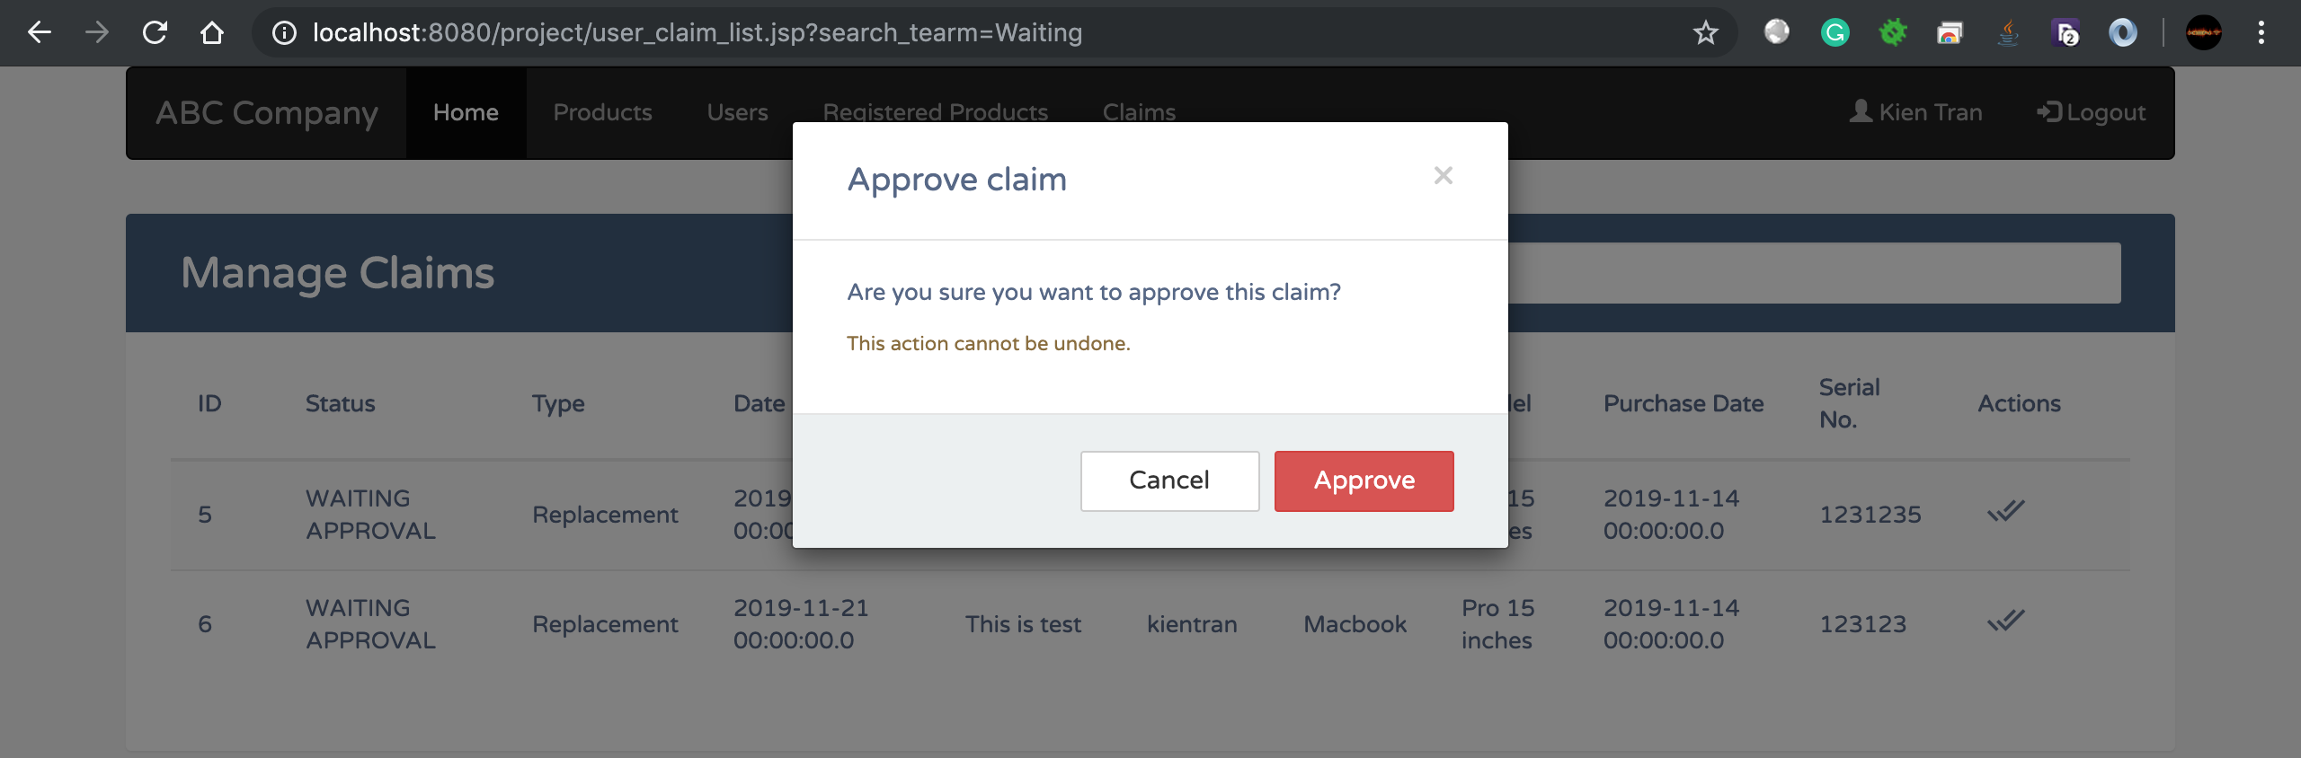

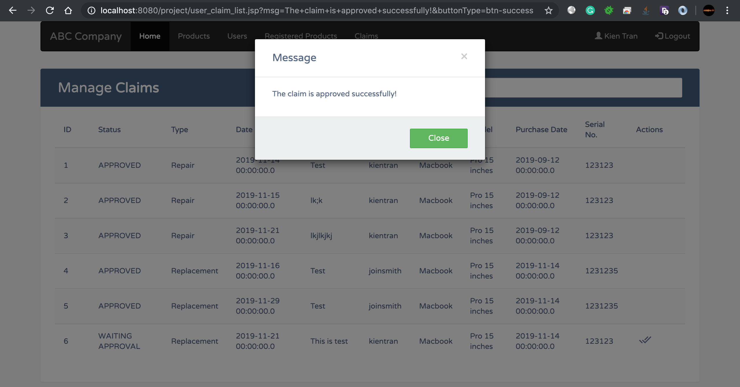

# Section 7: How to Deploy the Web application

(Explain and demonstrate how to deploy the web application—execute it outside the eclipses. *If you have answered the bonus question, you can demonstrate how to deploy the web application into a free webhost!*)

1. Export the project to war file

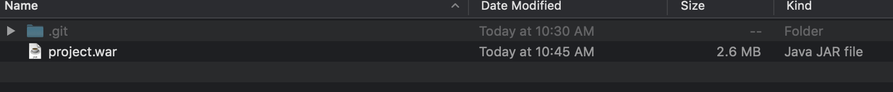

1. Copy war file to tomcat web folder

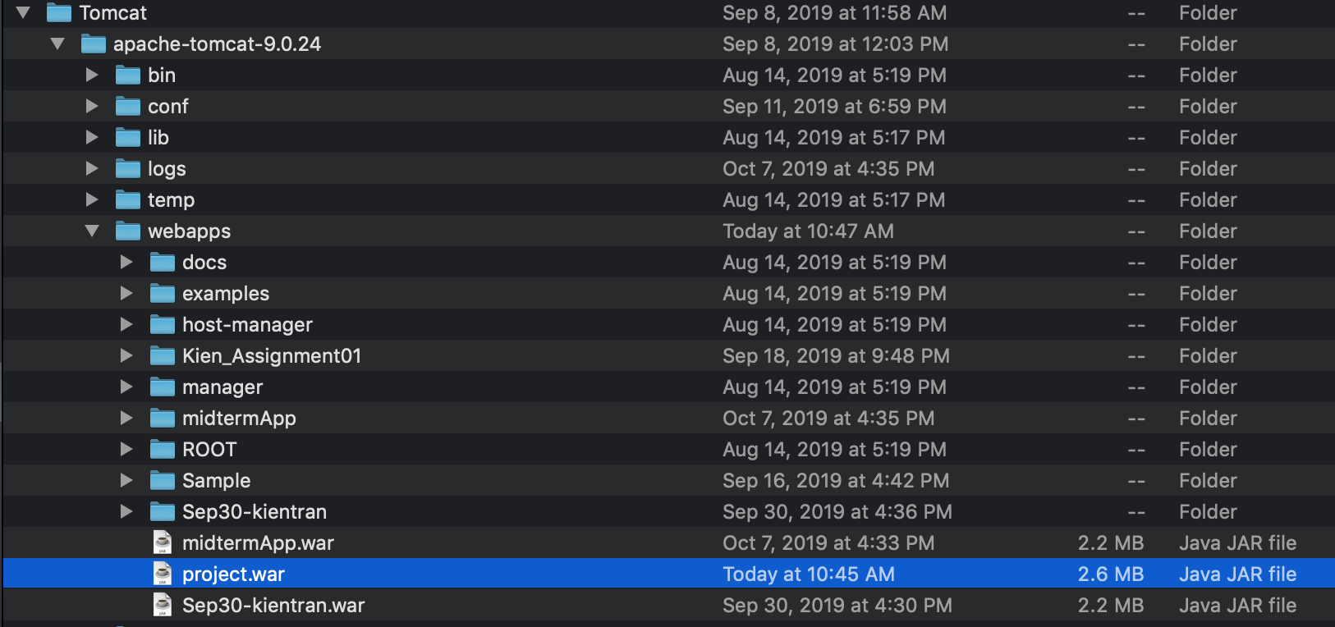

1. Start Tomcat

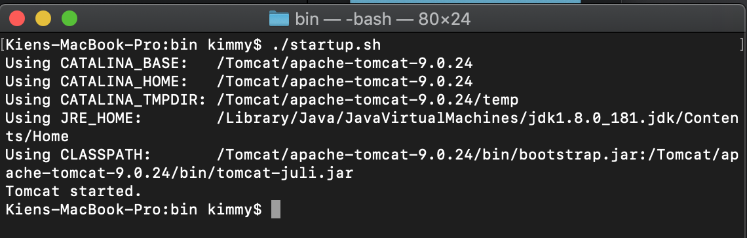

1. Access the webpage

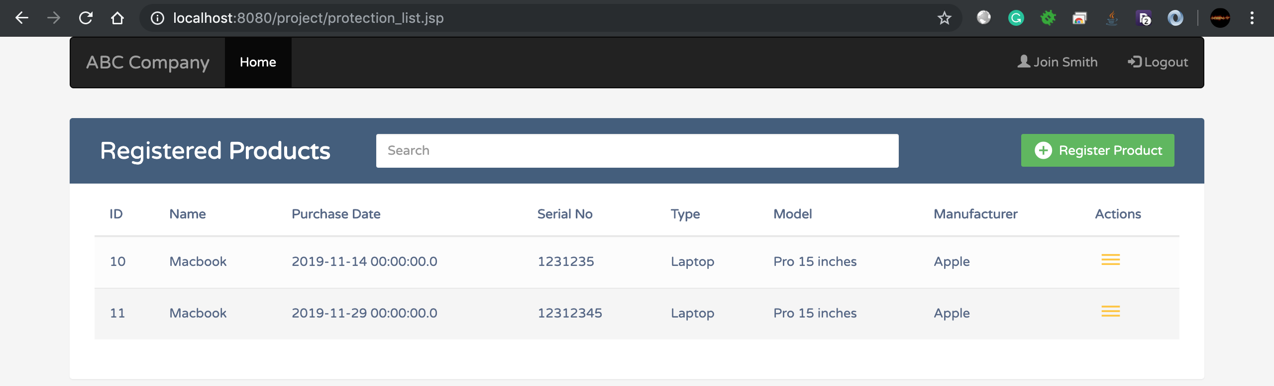

# Section 8: Project Feedback

(How did you manage team working in regards to sharing files/source codes, database files, …?

How do you evaluate your work? How do you evaluate your time management? How do you evaluate your experience in this project in term of team-working, programming skill, …? )

* We used github.com to share code between members
* We first created complete database structure for the project then fill up with dummy data. Finally, we share the sql dump file with each other through github.com
* How do you evaluate your work?
  + Good
* How do you evaluate your time management?
  + Good
* How do you evaluate your time management?
  + Good